SEVEN SEVEN GLOBAL SOFT · iOS DEVELOPMENT
iOS Development
A Training Manual & Video Script Guide
Foundations of UIKit, Swift and App Architecture
A topic-by-topic reference for building iOS apps — written both as a shot-ready video script and as a self-study workbook, with on-screen Xcode examples, matching iPhone screens, modern SwiftUI equivalents, practice exercises, and a closing module on documentation.
Field | Detail
Author | Miguel Joaquin A. Sanson
Prepared for | Seven Seven Global Soft Inc. — iOS Development training programme
Audience | Video editors producing the training series, and developers using it for self-study
Curriculum scope | 7 core topics — from Swift fundamentals to app architecture and device capabilities
Reference application | TicketPlease — a UIKit ticket-booking app used to ground every topic in real code
Tech stack | Swift 5 · UIKit · MVVM + Clean Architecture · iOS 17.5 · zero third-party dependencies
How to read it | As a video script (follow the cues) or as a workbook (read the topics, do the exercises)
Currency | All technical claims verified against Apple documentation and current sources, July 2026
Also includes | SwiftUI equivalents for every UIKit example · a testing chapter · a booking-flow diagram · practice exercises · an Xcode troubleshooting appendix
Version | 2.0 — 23 July 2026

How to Use This Document
This document does two jobs at once, and it is built so that neither gets in the way of the other. Read straight through, it is a production script: every line of narration, every piece of code, and every iPhone screen is placed in the order it should appear on camera, so a video editor can shoot from it without having to invent structure. Read as a reference, it is a workbook: each topic is self-contained, explains itself from first principles, ends with a practice exercise, and can be revisited on its own long after the video is finished. Nothing here assumes you attended a class — the manual teaches the material, and the script tells you how to film it.

Reading the cues
The markers below are the shared vocabulary of the document. If you are filming, they tell you what to put on screen; if you are studying, they simply mark what kind of information is coming next. Either way, they are the fastest way to navigate a page.
Marker | What it means
Plain paragraphs | The core explanation. On camera this is the narration; on the page it is the teaching text. Read it as written or paraphrase it into the presenter's own voice — the meaning is what matters, not the exact words.
[ON SCREEN — XCODE] | The moment to show the Xcode editor. The shaded code block directly beneath the cue is exactly what should be visible on screen while the narration continues.
[ON SCREEN — IPHONE] | Cut away from the code to the referenced iPhone screenshot, so the viewer sees the concept actually running. Every file is named in Appendix A.
[B-ROLL] | A supporting-footage suggestion — a device shot, a gesture close-up, a screen recording. Optional, but these are the moments that keep a technical video visually alive.
[GRAPHIC] | A diagram, table or animated build that belongs on screen as a visual rather than being read aloud word for word. The cue describes what to animate and in what order.
Shaded code blocks (grey) | Screen-ready Swift, written to fit a phone-shaped frame. Pick one Xcode theme, light or dark, and keep it consistent across the whole series.
Blue call-outs | A useful aside — context or a 'why it matters' point the narrator can deliver without breaking stride.
Amber call-outs | A gotcha, a mistake, or an easy-to-miss detail. On camera these earn a slow zoom or a highlight; in study they are the things worth writing down.
Red COMMON MISCONCEPTION boxes | A belief many beginners hold that is simply untrue, paired with the reality. Teach the reality, never the myth. Every one is verified with a source and collected in Appendix C.
Purple VERSION NOTE boxes | How the platform has moved since the era this material describes. Include them so the finished video does not teach something that is already out of date.
Teal SWIFTUI EQUIVALENT blocks | The same idea expressed in modern SwiftUI, placed beneath the UIKit version. Showing the two side by side is the single most valuable thing this series can do for a 2026 audience.
Parchment PRACTICE EXERCISE boxes | A hands-on task closing each topic, so a self-study reader can practise immediately. On camera they double as an end-of-episode challenge to set for the viewer.

WHY EVERY UIKIT EXAMPLE HAS A SWIFTUI TWIN The core curriculum is taught in UIKit, and that is deliberate: UIKit is what the overwhelming majority of existing production code is written in, and doing layout and navigation by hand first is what makes SwiftUI's shortcuts legible rather than magical. But anyone writing a brand-new screen in 2026 will reach for SwiftUI. Rather than force a choice, this guide shows both — the UIKit version, then the same idea in current SwiftUI directly beneath it. The teal blocks target iOS 17-and-later APIs (the @Observable macro, NavigationStack, async/await), not the older ObservableObject and NavigationView patterns that still dominate search results. On camera this is best staged as a split screen or a wipe from one to the other; in study it is a ready-made 'here is how this ages forward' comparison.

WHY THERE ARE MISCONCEPTION AND VERSION-NOTE BOXES iOS is a moving target, and some of the ideas that circulate about it are folklore rather than fact — 'UserDefaults is encrypted', 'you should always use Google Maps', 'map searches an array'. Each red box states one such myth and then the documented reality, so the video never repeats it and the self-study reader is inoculated against it. The purple boxes handle the other kind of drift: material that was perfectly accurate a version or two ago but has since changed. Both kinds are verified against Apple's documentation and current sources, and every one is collected with citations in Appendix C so a reviewer can check any single claim without re-reading the chapter it came from.

Suggested episode structure
The seven core topics map cleanly onto seven episodes, and the supporting chapters extend the series without disrupting that spine. Testing and documentation each stand on their own because they are craft skills rather than language features, and the troubleshooting appendix is deliberately modular so it can run as a standalone short or as a recurring closing segment. The runtimes below are estimates for a comfortable teaching pace; a faster edit can compress each by a few minutes without losing the core.
Episode | Source section | Approx. runtime
1 | Module 1 — iOS Fundamentals & Swift Basics | 10–12 min
2 | Module 2 — UIKit, MVVM, Auto Layout & Table Views | 12–15 min
3 | Module 3 — Intermediate Swift & Concurrency | 8–10 min
4 | Module 4 — Networking | 8–10 min
5 | Module 5 — Data Persistence & Security | 10–12 min
6 | Module 6 — Architecture Patterns & Dependency Injection | 8–10 min
7 | Module 7 — Maps, Notifications, Media & Animation | 10–12 min
8 | Chapter 9 — Testing | 8–10 min
9 | Chapter 10 — Documentation Best Practices | 8–10 min
Bonus | Appendix D — Common Xcode Errors. Works as its own short, or as a recurring 30-second segment closing each episode. | 5–8 min

THE CASE STUDY IS THE CONNECTIVE TISSUE Chapter 8's case study — requirements, then flowchart, then wireframe, then the finished build — is not really an episode of its own. It works best broken up and threaded through the series: open with the idea and the booking flowchart so viewers know where everything is heading, then return to the build timeline at the very end as the payoff that ties the seven topics together. The booking-flow diagram is the strongest single graphic in the whole document and earns screen time wherever it lands.

ABOUT THE SCREENS AND DIAGRAMS All 29 iPhone screenshots in this document are real captures from the finished TicketPlease build, embedded here at full resolution (1179 × 2556) and catalogued in Appendix A so an editor can pull the source files for higher-quality compositing. The booking-flow diagram in Chapter 8 is an original vector render supplied alongside the document. Where a concept benefits from a visual the reference app cannot provide, the text says so and suggests a supplementary graphic rather than leaving a gap.

Contents
BUILDING THE CONTENTS LIST In Google Docs: click the line below, then Insert → Table of contents. It builds automatically from the headings in this document and stays clickable. In Microsoft Word: right-click the field below and choose Update Field.

How to Use This Document 2
Contents 5
Part 0 — Curriculum Overview 6
0.1 How this curriculum is organised 6
0.2 Topic map 6
0.3 The reference application 7
Module 1 — iOS Fundamentals and Swift Basics 10
1.1 Orientation 10
1.2 Swift language foundations 12
1.3 Outlets and actions — the core mechanic 18
Module 2 — UIKit, MVVM, Auto Layout and Table Views 21
2.1 What UIKit is 21
2.2 MVVM, hands-on 21
2.3 View controller life cycle 24
2.4 Auto Layout and constraints 24
2.5 Navigation 26
2.6 Tab bars 27
2.7 Table views 29
2.8 Alerts, gestures, text fields and scroll views 30
Module 3 — Intermediate Swift and Concurrency 32
3.1 Overview 32
3.2 From idea to plan — the design workflow 35
Module 4 — Networking 37
4.1 Overview 37
Module 5 — Data Persistence and Security 44
5.1 Overview 44
Module 6 — Architecture Patterns and Dependency Injection 52
6.1 Overview 52
6.2 Dependency injection 53
Module 7 — Maps, Location, Notifications, Media and Animation 57
7.1 Overview 57
Chapter 8 — Case Study: Building a Complete App 64
8.1 From idea to finished app 64
8.2 Step 1 — Requirements 64
8.3 Step 2 — Flowchart 65
8.4 Step 3 — Wireframe 67
8.5 The build timeline 68
8.6 The complete booking flow 69
8.7 Two booking modes, one engine 70
Chapter 9 — Testing 73
9.1 Why testing matters here 73
A unit test reads like a specification 73
Fakes — the real payoff of protocol-based DI 74
Testing things that are genuinely hard to test 74
UI tests — tapping the app like a user 75
What the suite actually covers 77
Chapter 10 — Documentation Best Practices 78
10.1 Why documentation matters 78
10.2 The five parts of a documented change 78
10.3 A worked example — the reference app's change list 79
10.4 The full change list, in the recommended format 80
10.5 Documenting AI involvement 84
10.6 Documenting difficulties honestly 85
10.7 Templates to copy 86
10.8 Checklist 87
Appendix A — Screenshot Asset Index 88
Appendix B — Glossary 89
Appendix C — Accuracy, Misconceptions and Currency Notes 91
C.1 Misconceptions to correct 91
C.2 Currency updates 92
C.3 Added — topics a modern viewer will ask about 92
C.4 Sources 93
Appendix D — Common Xcode Errors and How to Fix Them 94
D.1 Storyboard and connection errors 94
D.2 Runtime crashes 95
D.3 Silent failures — nothing crashes, nothing happens 95
D.4 Debugging techniques from the sessions 96
D.5 Build and environment problems 96
D.6 The debugging order used in the sessions 97

Part 0 — Curriculum Overview

0.1 How this curriculum is organised
The material is built in seven topics that deliberately climb from the ground up. The first establishes the language and the tools; the next adds the interface layer; the middle topics layer on the language features, networking and storage that turn a screen into an app; and the final topics cover architecture and the device capabilities that make an app feel native. Each topic is designed to be learned by building something with it, not merely by reading about it — which is why every chapter closes with a practice exercise, and why a single reference application runs through all of them.
One principle sits underneath the whole curriculum and is worth stating plainly at the very start, because it shapes how every later topic should be judged: an app is allowed to be unfinished, and it is allowed to have bugs, but it is never allowed to crash. A rough layout or a missing feature is a work in progress. A crash is a broken promise to the person holding the phone. That single standard — correctness and stability before polish — is the reason optionals, guard statements, error handling and safe unwrapping recur as themes from the very first topic onward.

0.2 Topic map
[GRAPHIC] Animate this table one row at a time as the narrator names each topic, so the viewer sees the curriculum assemble from the ground up. Consider colour-coding the four bands — language, interface, data, and architecture/device — so the climb is visible at a glance.
# | Topic | What it covers | Practice outcome
1 | iOS Fundamentals & Swift Basics | What iOS development is · the Apple ecosystem · Xcode install & system requirements · Swift basics · optionals · error handling · collections · struct vs class · protocols · MVC/MVVM intro · Foundation · URLSession · JSON · ARC | Build a Calculator UI, connecting controls as outlet and as action.
2 | UIKit, MVVM & Auto Layout | UIKit introduction · MVVM in practice · the view controller life cycle · Auto Layout & constraints · storyboards vs XIBs · navigation · tab bars · programmatic UI · table & collection views · gestures · alerts · text fields · scroll views | Lay the calculator out with stack views and constraints; build an image-and-detail table view.
3 | Intermediate Swift & Concurrency | Closures · escaping vs non-escaping · generics · protocol-oriented programming · map/filter/reduce · the Result type · error propagation · ARC & retain cycles · GCD · async/await · actors | Design an app concept with MVVM: requirements, flowchart and wireframe.
4 | Networking | Networking fundamentals · URLSession · HTTP methods · Codable · encoding/decoding JSON · CodingKeys · API-client architecture · environment configs · headers & tokens · retry logic · async image loading · dependency managers | Wire a screen to a live or mock API and decode its JSON into models.
5 | Data Persistence & Security | Data persistence · UserDefaults · FileManager · Core Data · Keychain services · access groups | Persist app data locally and store a credential securely in the Keychain.
6 | Architecture & Dependency Injection | Architecture patterns · MVC · MVVM · Clean Architecture layers · dependency injection · singleton · protocol-based DI · the factory pattern | Refactor a screen so its logic sits behind protocols and is injected, not hard-wired.
7 | Maps, Notifications, Media & Animation | MapKit · Core Location · Info.plist permissions · APNs push notifications · camera & photo picker · PHPicker · file access · AVFoundation preview · UIView animation · Core Animation · Lottie | Add a map with live pins and schedule a local notification.

TWO CRAFT CHAPTERS BEYOND THE SEVEN TOPICS The seven topics above are language and framework skills. Two further chapters cover craft that no single API teaches: Chapter 8 on testing, which turns the architecture of Topic 6 into something you can actually verify, and Chapter 9 on documentation, which is the practice that lets any of this work be handed to someone else. Both are treated as first-class material rather than footnotes, because in professional work they are precisely what separates code that survives from code that is quietly rewritten.

0.3 The reference application
Every topic in this guide is demonstrated twice: once in isolation, as a small self-contained snippet that shows the idea with nothing else in the way, and once in context, as it actually appears in a complete application. That application is TicketPlease, a ticket-booking app for movies, concerts and seminars, built entirely in UIKit with the same MVVM and Clean Architecture the curriculum teaches. Grounding the material in one real, coherent app is what keeps it honest — a viewer sees a concept explained, and then sees the production-shaped version of that exact concept running on a phone, wired into a real feature rather than a toy.
TicketPlease is deliberately production-shaped rather than production-complete: it holds real content, persists real data, and enforces real rules, but it runs entirely on-device with no backend. That makes it an ideal teaching vehicle, because every layer is visible and nothing is hidden behind a server. The figures below give a sense of its scope.
By the numbers | Value
Bookable items | 30 — 10 movies, 15 concerts, 5 seminars
Cinemas | 8 — six standard at PHP 350, two VIP at PHP 550
Swift source files | 137
Feature milestones | 11 dated build milestones across roughly three weeks
Third-party dependencies | 0 — 100% native Apple frameworks
Persistence mechanisms | FileManager JSON · plist · UserDefaults · Keychain · URLSession cache

[ON SCREEN — IPHONE] Open the whole series with this six-shot montage of the finished app, before the first topic begins. Let each screen breathe for a beat — this montage is the promise of what a viewer will be able to build by the end, so it should feel aspirational rather than rushed. A subtle push-in on each screen adds motion without distraction.
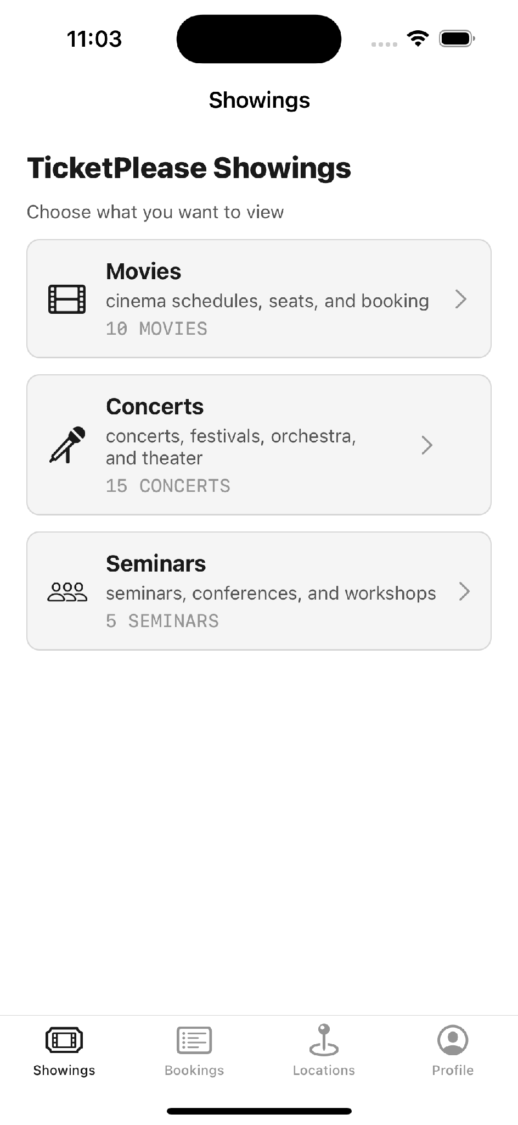 | 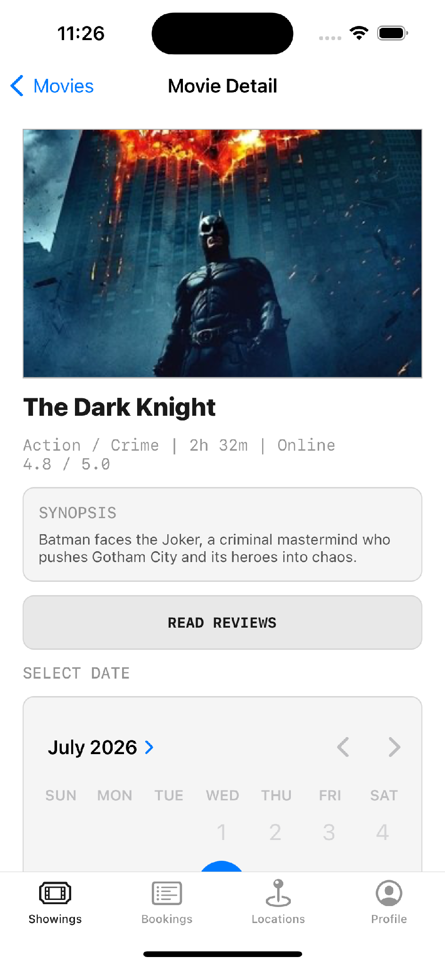 | 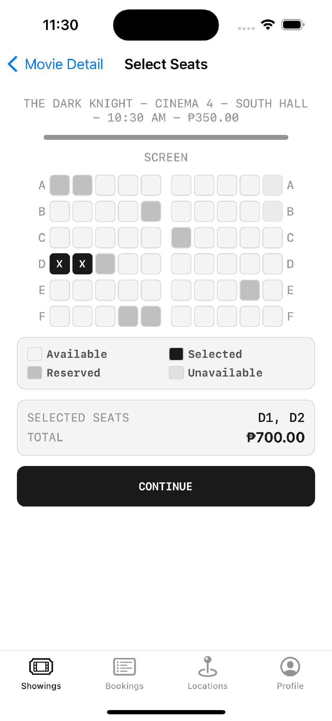
Showings hub | Movie detail | Seat selection

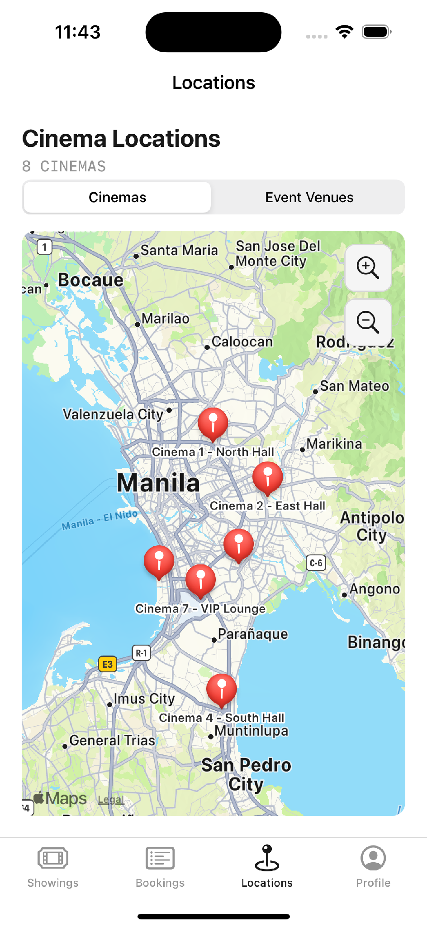 | 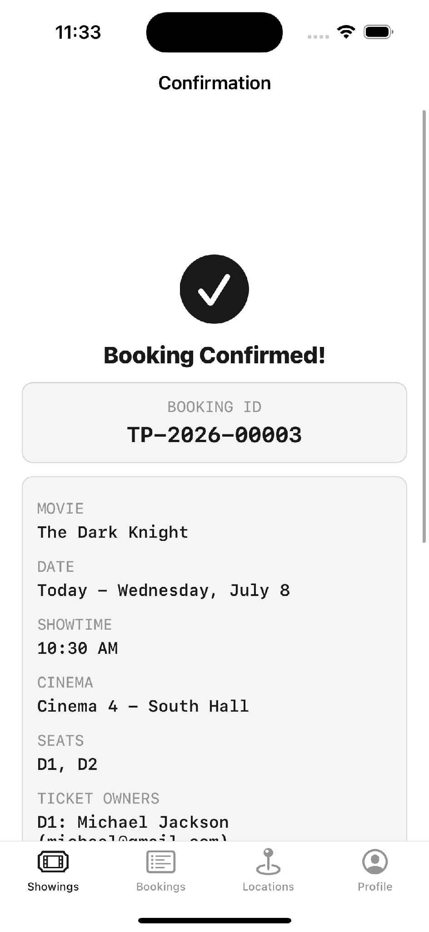 | 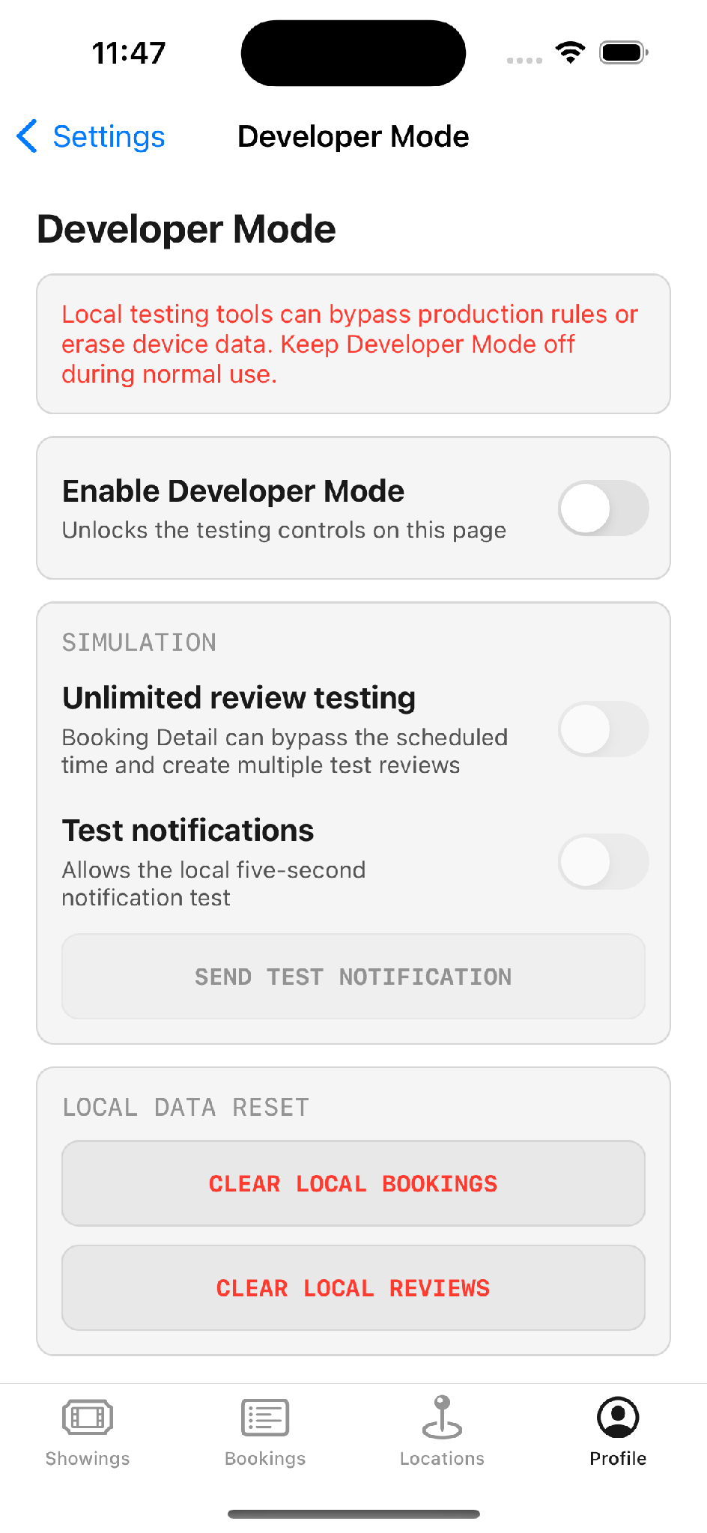
Locations map | Confirmation | Developer Mode

Module 1 — iOS Fundamentals and Swift Basics
TOPIC 1 What iOS development is, the Apple ecosystem, Xcode installation and system requirements, and the full Swift language foundation — variables, types, control flow, functions, optionals, error handling, collections, struct vs class, protocols, and the concepts (MVC/MVVM, Foundation, URLSession, JSON, ARC) that later topics build on.

1.1 Orientation
This topic has two halves, and they are best filmed in that order. The first is orientation: what iOS development actually is, what hardware and software it requires, and how to get a first project building and running. The second is a fast, wide pass over the Swift language itself — enough of every core idea that the rest of the curriculum has something to stand on. By the end of it a learner should have a project that builds, a function that runs, and a button wired to code.
iOS development means building for Apple's platforms: iPhone, iPad, Apple Watch and Apple TV. The language is Swift. Before Swift there was Objective-C, which still appears in older codebases; after Swift came SwiftUI, the newer declarative framework. This curriculum builds on Swift with UIKit, for a specific reason worth stating on camera: you cannot really understand what SwiftUI does for you until you have done the same work by hand in UIKit first. Learning the manual version makes the shortcut legible instead of magical.

A precise timeline, for the on-screen graphic
Date | Event
1984 – 2014 | Objective-C is the primary language for Apple platforms.
2 June 2014 | Apple announces Swift at WWDC, alongside a pre-release Xcode 6.
15 September 2014 | Swift 1.0 ships.
3 December 2015 | Swift is open-sourced under the Apache 2.0 licence.
June 2019 | SwiftUI announced — declarative UI, alongside rather than replacing UIKit.
Today | Swift 6.3, shipping with Xcode 26. UIKit is fully supported and not deprecated.

PRECISION FOR THE TIMELINE GRAPHIC It is easy to remember Swift as having arrived vaguely 'around 2014 to 2016'. The exact date is 2 June 2014, announced at WWDC — use the precise figure in the on-screen timeline, because a dated graphic reads as authoritative where a fuzzy one does not.

VERSION NOTE (2026) Is UIKit still worth learning in 2026? Yes — and it is worth addressing head-on, because it is the first question a curious viewer will have. UIKit is actively maintained and not deprecated; Apple's own Settings, Messages and Photos apps still lean on UIKit components. A 2025 developer survey found roughly 43% of respondents still UIKit-only and a further 22% running a deliberate UIKit-plus-SwiftUI hybrid. The honest framing: SwiftUI is the sensible default for a brand-new screen, but UIKit is what the majority of existing production code is written in, and the two interoperate cleanly — so time spent learning UIKit is not time wasted, it is time spent on the codebases that actually exist.
Source: 7span.com/blog/swiftui-vs-uikit · nevinainfotech.com/blog/swiftui-vs-uikit

[B-ROLL] An Apple device-family shot — iPhone, iPad, Watch and TV together — while the narrator lists the platforms Swift targets. A slow pan across the devices, or a simple animated line-up, sells the point that 'iOS development' really means a whole ecosystem rather than one phone.

Tooling and system requirements
The numbers below come in two columns for a reason. The left column reflects the comfortable minimums for the era this material was first taught; the right column reflects what a current Xcode actually demands. Because anyone watching will be on a current Xcode, narrate the right-hand column — but the comparison is instructive in itself, since it shows how quickly the platform's baseline moves.
Requirement | Era baseline | Current (Xcode 26.x, July 2026)
Machine | A Mac is mandatory (Mac Mini or better). | Unchanged. Apple silicon strongly preferred; AI features require it.
IDE | Xcode, free from the Mac App Store | Unchanged — code editor, Interface Builder, simulator and debugger
macOS | Latest or near-latest (Sonoma-era) | Xcode 26.6 requires macOS Tahoe 26.2 or later
RAM | 8 GB minimum, 16 GB recommended | 16 GB is the realistic baseline; Predictive Code Completion requires 16 GB unified memory
Storage | At least 20 GB free | Budget considerably more once simulators and platform SDKs are installed
Apple Account | Required to download Xcode | Unchanged. A free account is enough to build and run on a device.
Physical device | Optional for learning; required for production | Unchanged — not every capability exists in the simulator

VERSION NOTE (2026) Two version facts belong up front, because they are what date the material fastest. First, the current toolchain is Xcode 26.x with Swift 6.3, targeting iOS 26; the code and concepts in this guide were written against iOS 17.5, and every one of them still applies unchanged. Second, and more consequential for anyone intending to ship: since 28 April 2026 every app submitted to App Store Connect must be built with the iOS 26 SDK or later using Xcode 26 or later, with no grace period. Learning against an older SDK is fine; releasing against one is no longer possible.
Source: developer.apple.com/documentation/xcode-release-notes/xcode-26_6-release-notes

THE SIMULATOR IS NOT THE WHOLE STORY A point that saves real grief later: the simulator is excellent for building and iterating, but it is not a substitute for a physical device. Several hardware capabilities — the camera, certain sensors, some performance characteristics — simply do not exist in it. The working rule for a mobile developer is that you have your computer and you have your devices, and anything hardware-bound is verified on the latter before it is trusted.

Creating the first project
The starting point for every app is the same: New Project, iOS, App. The template then asks for a handful of settings, and while most can be accepted as-is, two of them matter more than they first appear and are worth pausing on.
- Team: Leave it as None while learning — assigning a real team requires a paid Apple Developer account, which is not needed to build and run.
- Bundle identifier: This is the app's unique identity, and it is the field to get right. No two apps on the App Store share one. If someone else registers your bundle ID first, you cannot claim it — it can only be transferred by agreement between Apple accounts.
- Interface: Storyboard, not SwiftUI — this selects UIKit.
- Language: Swift, not Objective-C.
- Storage: Leave as None while learning — Core Data is covered later, in Topic 5.
GOTCHA Xcode generates AppDelegate, SceneDelegate, ViewController, Main.storyboard, LaunchScreen and Info.plist. Do not delete any of them. AppDelegate in particular is the first thing that fires when the app opens — remove it and the project breaks.

1.2 Swift language foundations

Variables and constants
Swift has two declarations and the naming trips up developers coming from Android, where 'var' means something different. In Swift, var is mutable and let is a constant. You can change what a var holds, as long as the type stays the same. A let is fixed once assigned.
[ON SCREEN — XCODE] Type these two lines live; let the error appear when reassigning the constant.
Swift — var vs let
var score = 10 // mutable — can be updated later
score = 25 // fine

let age = 25 // constant — fixed forever
// age = 30 // compiler error: cannot assign to value 'age'

Data types and operators
Type | Holds | Example
Int | Whole numbers | let count = 12
Double | Decimal numbers | let rating = 4.7
String | Text | let title = "Inception"
Bool | True or false | let isNowPlaying = true
Character | A single character | let grade: Character = "A"
Array | An ordered list, accessed by index | let seats = ["A1", "A2"]
Dictionary | Key/value pairs, accessed by key | let user = ["name": "Ava"]

Arrays and dictionaries deserve extra attention because they are what you will actually meet when parsing JSON — nested arrays of dictionaries, dictionaries of arrays, and every combination in between. Operators are conventional: arithmetic, comparison, and logical.

Control flow
[ON SCREEN — XCODE] Show the if/else first, then point out the missing parentheses compared to Java/Kotlin.
Swift — control flow
// if / else — note: no parentheses required around the condition
if score > 20 {
print("High score")
} else {
print("Keep trying")
}

// switch
switch day {
case "Monday":
print("Start of the week")
case "Friday":
print("Almost weekend")
default:
print("Ordinary day")
}

// loops
for index in 1...5 {
print(index)
}

var count = 0
while count < 5 {
count += 1
}

Functions and the camelCase convention
Functions use the func keyword, a name, typed parameters, and an optional return type. The naming convention matters here and it is a genuine difference from other ecosystems: iOS uses camelCase, not snake_case. First word lowercase, every subsequent word capitalised — like the humps on a camel, which is where the name comes from.
Swift — declaring and calling a function
func iosTraining(name: String, age: Int, gender: String, isPass: Bool) {
print(name)
print(age)
print(gender)
print(isPass)
}

// Calling it — no 'func' keyword, just the name and its arguments
iosTraining(name: "Ava", age: 18, gender: "female", isPass: true)

WHY viewDidLoad EXISTS Every new ViewController arrives with a viewDidLoad method already written. That is the first step of the view controller life cycle — it fires once when the view loads. Initialisation, setup and first API calls go here. Module 2 covers the rest of the life cycle.

Optionals
Optionals are Swift's safety net around missing data, and they are the single most important concept from day one. A question mark marks a value that may or may not be there. An exclamation mark force-unwraps and asserts that a value is always present — which is exactly how you get a crash when it is not.
The reason this matters is that most crashes in a mobile app come from data. You expect a field, the API returns nothing, and the app dies. Optionals stop that.
Swift — optionals and safe unwrapping
// Optional — may hold a String, or nothing at all
var nickname: String?

// Nil-coalescing: supply a fallback when the value is missing
let user: [String: String] = [:]
print(user["name"] ?? "Unknown") // prints "Unknown" instead of crashing

// Optional binding — the safe way to unwrap
if let name = user["name"] {
print("Welcome, \(name)")
}

Error handling
Swift — enum error type, throws, do/try/catch
enum LoginError: Error {
case invalidCredentials
}

func login(username: String, password: String) throws -> String {
guard username == "admin" else {
throw LoginError.invalidCredentials
}
return "Login successful"
}

do {
let result = try login(username: "guest", password: "1234")
print(result)
} catch {
print("Login failed: \(error)")
}

Collections: arrays, dictionaries, sets and tuples
One question is worth putting to the viewer directly, because the answer teaches a habit. Can you mix strings and numbers in a single array? Technically yes, by typing it as an array of Any — but you should not. Keeping a collection to a single type is the best practice, because the moment you mix types you inherit the problem of untangling them again on the other side, every time you read the collection. A uniform collection is a promise about what is inside it.
Swift — collection types
// Array — ordered, allows duplicates
let numbers = [1, 2, 3, 4]

// Dictionary — key/value
let user = ["name": "Ava", "role": "developer"]
print(user["name"] ?? "Unknown")

// Set — unordered, no duplicates
let uniqueSeats: Set<String> = ["A1", "A2", "A1"] // stores A1 and A2 only

// Tuple — a lightweight grouping of related values
let person = (name: "Ava", age: 25)
print(person.name)

Struct vs class
A struct is a value type. A class is a reference type. The practical rule taught in the training is simple and it is the rule the app follows throughout: use structs for models and data, use classes for behaviour and functionality.
 | struct | class
Semantics | Value type — copied on assignment | Reference type — shared instance
Used for | Models, JSON parsing, Codable payloads | View models, services, controllers
Inheritance | No | Yes
In TicketPlease | Movie`, `Booking`, `Review`, `AppSettings | MoviesViewModel`, `BookingStore`, `AuthenticationService

[ON SCREEN — XCODE] Open Models/Movies/Movie.swift from the real project.
TicketPlease — Models/Movies/Movie.swift (the real model, straight from the app)
import Foundation

// module 1 codable movie model
// poster url is fallback while localPosterName points to bundled offline image
struct Movie: Codable, Equatable {
let title: String
let tmdbID: Int?
let genre: String
let duration: String
let rating: Double
let synopsis: String
let posterURLString: String?
let localPosterName: String?
let isNowPlaying: Bool
let isComingSoon: Bool
}

TIE IT TOGETHER Notice the optionals in that struct: tmdbID, posterURLString and localPosterName are all optional because a film may not have a TMDB entry or a bundled poster. That is the Day 1 optionals lesson doing real work in production code.

[ON SCREEN — IPHONE] Show the movies list — this is the Movie struct rendered.
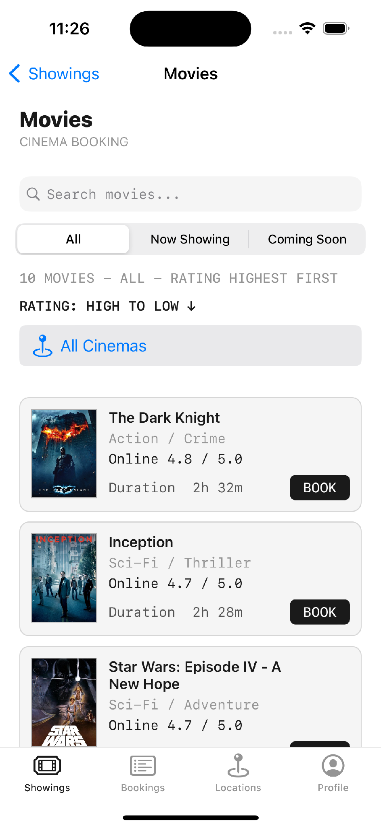
Movies list — each row is one Movie struct | Movie detail — the same struct, expanded

Enums
Swift — enums, used for statuses, categories and error cases
enum Direction {
case north, south, east, west
}

// In TicketPlease — Models/Movies/CinemaType.swift
enum CinemaType {
case standard // PHP 350
case vip // PHP 550
}

Protocols
Protocols are contracts. You declare a set of functions, and any struct or class that adopts the protocol must provide them — but each one can implement them differently. Think of it as a flexible global interface you can adapt per type. This becomes the backbone of dependency injection in Module 6.
Swift — protocol with two different conformances
protocol Flyable {
func fly()
}

struct Bird: Flyable {
func fly() {
print("Bird is flying")
}
}

struct Plane: Flyable {
func fly() {
print("Plane is flying")
}
}

MVC and MVVM — first look
This is the architecture question that Topics 2 and 6 return to in depth; introduced here in outline so the vocabulary is familiar before it matters. In MVC — Model, View, Controller — the model and the view can never talk to each other directly. The controller sits between them, updating the model and pushing the results back to the interface.
MVVM keeps the same idea but replaces the controller with a view model, and the crucial difference is reuse: one view model can serve several views, where MVC tends toward one controller per screen. From it follows the single rule to repeat throughout the whole curriculum — no data handling, no parsing, no API calls in the view. All of that belongs in the view model, and the view exists only to display what the view model hands it.
[GRAPHIC] Animate two diagrams side by side: MVC (Model ↔ Controller ↔ View) and MVVM (Model ↔ ViewModel ↔ many Views). Draw the MVVM side second and let the 'many Views' fan out from a single view model, so the reuse advantage is something the viewer sees rather than just hears.

Foundation, URLSession, JSON and ARC
The topic closes by previewing three things that Topics 4 and 5 cover properly, so they are not strangers when they arrive: the Foundation framework for dates, calendars and timers; URLSession for network calls; and Codable for turning JSON into Swift types.
The Codable point is the one that tends to land hardest, because it replaces a genuine chore. Parsing JSON used to mean pulling values out of a dictionary key by key, line after line, and the code grew without limit as the payload did. With Codable the whole thing collapses to a single line.
Swift — why Codable replaced manual dictionary parsing
struct User: Codable {
let name: String
}

// The old way — one line per field, and it grew forever
// let name = dictionary["name"] as? String
// let age = dictionary["age"] as? Int

// With Codable — one line
let user = try JSONDecoder().decode(User.self, from: jsonData)

ARC — Automatic Reference Counting — rounds out the topic. Before ARC, iOS developers released memory by hand, and forgetting to do it caused memory leaks and, eventually, crashes. ARC handles that release automatically. Memory still has to be reasoned about — through concurrency and through weak references, both of which Topic 3 covers — but the manual, error-prone release calls are gone.

1.3 Outlets and actions — the core mechanic
Before the exercise, one mechanic underpins all of UIKit and deserves its own moment: connecting an interface control to code in two distinct ways. An outlet connects the control as an object, so code can reach in and change it — enable it, disable it, restyle it, read its value. An action connects the control's behaviour, so a piece of code runs when the user interacts with it. A button usually needs both, and confusing the two is the source of a whole family of beginner bugs catalogued later in Appendix D.
Xcode — Ctrl-drag from Interface Builder produces exactly this
class ViewController: UIViewController {

// Outlets go above viewDidLoad — the button as an object
@IBOutlet weak var saveBtn: UIButton!
@IBOutlet weak var deleteBtn: UIButton!

override func viewDidLoad() {
super.viewDidLoad()
}

// Actions go below — the button's behaviour
@IBAction func saveAction(_ sender: Any) {
print("Save success")
}

@IBAction func deleteAction(_ sender: Any) {
print("Delete success")
}
}

SWIFTUI EQUIVALENT No outlets, no actions, no Ctrl-drag — the view and its behaviour are one declaration.
struct ContentView: View {
var body: some View {
VStack(spacing: 16) {
Button("Save") { print("Save success") }
Button("Delete") { print("Delete success") }
}
}
}

A GOOD MOMENT TO PAUSE ON This is the clearest possible demonstration of what SwiftUI changed. The UIKit version needs a storyboard, two outlets, two actions and a physical drag gesture to connect them. The SwiftUI version is six lines and there is nothing to connect — which is exactly why the "class is not key value coding-compliant" crash in Appendix D cannot happen in SwiftUI.

[B-ROLL] Screen-record the Ctrl-drag gesture from a storyboard button into the code editor, slowly, with the connection pop-up visible. This is the single most useful visual in the whole topic — the gesture is hard to describe in words and instantly obvious once seen, so give it a clean, unhurried take and consider a gentle zoom on the blue connection line as it is dragged.

A common first attempt, and the better way
Picture a first version of the calculator that works perfectly but was built the long way. Every button is created and styled individually, by hand, so the same styling code is copy-pasted a dozen times and each of the ten digit buttons has its own separate action. It runs — but it feels hard-coded, and something about all that repetition suggests there must be a cleaner approach. This is the single most common shape a first UIKit screen takes, and recognising the smell is the first step to fixing it.
There is a cleaner approach, and it is a genuinely useful UIKit technique worth putting on screen. Instead of one action per button, give each button a tag in the Attributes Inspector, group the buttons by purpose — numbers, operators, clear — and give each group a single action that reads the sender's tag to decide what to do.
The fix — tags plus arrays instead of one function per button
// One action for all ten number buttons, distinguished by tag
@IBAction func numberPressed(_ sender: UIButton) {
let digit = sender.tag // tag 0...9 set in the Attributes Inspector
display.text = (display.text ?? "") + String(digit)
}

// A separate action grouping the operators
@IBAction func operatorPressed(_ sender: UIButton) {
// tag 10 = +, 11 = -, 12 = ×, 13 = ÷
}

// Styling many buttons at once, instead of one at a time
let allButtons = [button0, button1, button2, button3, button4]
for button in allButtons {
button.layer.cornerRadius = 8
button.titleLabel?.font = .systemFont(ofSize: 24)
}

WHY BUILD IT THE LONG WAY FIRST It is tempting to teach only the elegant version, but there is real value in meeting the repetitive one first. Feeling the pain of a dozen near-identical buttons is what makes the tag technique memorable — the solution sticks because the problem was felt before it was solved. For a self-study reader, the lesson is the same: your first version being clumsy is not a failure, it is the raw material the refactor improves on.

✎ PRACTICE EXERCISE Build a Calculator UI
Brief. Create a single-screen calculator interface and wire its controls to code. The goal is not a working calculator engine — it is fluency with the two ways a control connects to code, which is the foundation every later UIKit topic assumes.
Your tasks
1. Create a new iOS App project (Storyboard interface, Swift). Set a meaningful bundle identifier and leave Team as None.
2. Lay out a calculator face in the storyboard: a display label and buttons for digits 0–9 and the four operators.
3. Connect the display label as an @IBOutlet so code can read and change its text.
4. Connect at least one button as an @IBAction and print a message when it is tapped, to confirm the wiring works.
5. Give the digit buttons tags in the Attributes Inspector and route them through a single grouped action that reads sender.tag.
6. Run on the simulator and confirm each tapped button reaches your code.
You have succeeded when
✓ Tapping a button prints or displays something — the action fires.
✓ Code can change the display label's text — the outlet is connected.
✓ One grouped action handles all ten digits, distinguished by tag, rather than ten separate actions.
Stretch goal. Add real arithmetic so the calculator actually computes results — but keep every value safely unwrapped, so that dividing by zero or an empty display never crashes the app.

Module 2 — UIKit, MVVM, Auto Layout and Table Views
TOPIC 2 UIKit and the MVVM pattern, the view controller life cycle, Auto Layout and constraints, storyboards and XIBs, navigation, tab bars, programmatic UI, table and collection views, gestures, alerts, text fields and scroll views. This is the longest topic in the curriculum, and the one that turns a pile of Swift syntax into something that behaves like an app.

2.1 What UIKit is
This is the densest topic in the curriculum, and the one that first makes the material feel like real app development. UIKit is Apple's long-established interface framework, built on views, view controllers, and an event-driven architecture in which the user acts and the code responds. The calculator from Topic 1 was already UIKit without the name attached; this topic gives the framework its name and then goes deep into how its pieces fit together.

2.2 MVVM, hands-on
The clearest way to learn MVVM is to build the smallest possible version of it from scratch: three folders — Model, ViewModel and View — with one file in each. The entire point is the separation of responsibilities. The model holds data. The view model owns logic and formatting. The view controller only displays what it is given. Once that division feels natural on a trivial example, it scales to an entire application without changing shape.
[ON SCREEN — XCODE] Show the three folders — Model, ViewModel, View — appearing one at a time in the Project Navigator, then open each file in turn so the viewer sees how little goes in each. The visual point is that no single file is doing everything; let the empty simplicity of the view controller land before moving on.
Model/User.swift
// Model — a struct, because it holds data
struct User {
var name: String
var age: Int
}

ViewModel/UserViewModel.swift
// ViewModel — a class, because it holds behaviour
class UserViewModel {
private var user: User

init(user: User) {
self.user = user
}

var displayName: String {
"Name: \(user.name)"
}

var displayAge: String {
"Age: \(user.age)"
}
}

View/ViewController.swift — note it never references User directly
import UIKit

class ViewController: UIViewController {

override func viewDidLoad() {
super.viewDidLoad()

let user = User(name: "Ava", age: 25)
let viewModel = UserViewModel(user: user)

// The view controller never touches the model directly
print(viewModel.displayName)
print(viewModel.displayAge)
}
}

SWIFTUI EQUIVALENT The MVVM split is identical — only the binding mechanism changes.
import SwiftUI

// iOS 17+: the @Observable macro replaces ObservableObject.
// Every stored property is observable — no @Published needed.
@Observable
final class UserViewModel {
private var user: User

init(user: User) { self.user = user }

var displayName: String { "Name: \(user.name)" }
var displayAge: String { "Age: \(user.age)" }
}

struct UserView: View {
// @State, not @StateObject — that pairing changed with @Observable
@State private var viewModel = UserViewModel(user: User(name: "Ava", age: 25))

var body: some View {
VStack(alignment: .leading) {
Text(viewModel.displayName)
Text(viewModel.displayAge)
}
}
}

THE PATTERN SURVIVES THE FRAMEWORK Worth stating explicitly on camera, because it is the reassurance the audience needs: MVVM is not a UIKit idea. The model still holds data, the view model still owns logic and formatting, the view still only displays. Everything Module 2 teaches about separation transfers to SwiftUI unchanged — you swap how the view observes the view model, not how you structure the app.

VERSION NOTE (2026) If you search for SwiftUI MVVM examples you will find two generations of code, and mixing them causes real confusion. The older pattern is class ViewModel: ObservableObject with @Published properties, observed via @StateObject or @ObservedObject. The current pattern, from iOS 17, is @Observable with plain properties, observed via @State. The distinction that trips people up: use @StateObject with ObservableObject, but @State with @Observable. The newer macro also observes at property level rather than object level, so it triggers fewer unnecessary redraws.
Source: developer.apple.com — Observation · donnywals.com/observable-in-swiftui-explained

THE RULE The view controller has no data logic in it at all. It asks the view model for a formatted string and displays it. Once a table view is involved, this extends further: even the delegate and data source arrays live in the view model, not the controller.

The same pattern in the real app
[ON SCREEN — XCODE] Open ViewModel/MoviesViewModels.swift. Scroll to filteredMovies.
TicketPlease — the search and sort logic lives entirely in the view model
// module 2 movies viewmodel
// search filters and rating sorting stay out of the view controller
final class MoviesViewModel {
private let movies: [Movie]
var searchText = ""
var ratingSortOrder: RatingSortOrder = .highestFirst
var selectedCategory: MovieCategory

var filteredMovies: [Movie] {
let matchingMovies = movies.filter { movie in
let matchesSearch = searchText.isEmpty ||
movie.title.localizedCaseInsensitiveContains(searchText) ||
movie.genre.localizedCaseInsensitiveContains(searchText)

let matchesCategory: Bool
switch selectedCategory {
case .all: matchesCategory = true
case .nowPlaying: matchesCategory = movie.isNowPlaying
case .comingSoon: matchesCategory = movie.isComingSoon
}

return matchesSearch && matchesCategory
}

return matchingMovies.sorted { first, second in
ratingSummary(for: first).effectiveRating >
ratingSummary(for: second).effectiveRating
}
}
}

[ON SCREEN — IPHONE] Type in the search bar and toggle the rating sort. Every visible change is driven by the code above.
Search, category filter and rating sort | The Showings landing that routes into it

2.3 View controller life cycle
Every view controller moves through a fixed sequence, and knowing which method fires when is what stops a whole class of bugs. viewDidLoad runs once, when the view loads. viewWillAppear runs every time the screen is about to appear — which is the one you want when returning to a screen and needing fresh data.
Method | Fires | Typical use
init | On creation | Dependency injection
loadView | Before the view exists | Rarely overridden
viewDidLoad | Once, after the view loads | Setup, initialisation, first data fetch
viewWillAppear | Every time, before appearing | Refresh data that may have changed
viewDidAppear | Every time, after appearing | Animations, analytics
viewWillDisappear | Before leaving | Save state, cancel work
viewDidDisappear | After leaving | Teardown

2.4 Auto Layout and constraints
This is, almost universally, the part of UIKit that newcomers find hardest — and it is worth saying so plainly on camera, because naming the difficulty normalises it. A learner struggling with constraints is not falling behind; they are exactly where everyone is at this stage. The concept is not deep, but it is fiddly, and it rewards patience more than cleverness.
The history explains the design. Apple originally shipped one iPhone screen size, so layout was simple. Once the range expanded — Pro, Pro Max, SE, iPad — a system was needed that could scale a layout across all of them. That system is Auto Layout.

The coordinate system and the four edges
The origin, 0,0, is the top-left corner. Constraints come in four flavours: top, bottom, leading and trailing. Leading and trailing rather than left and right, because they follow reading direction — leading is where you start reading, trailing is where you finish. That makes the same layout work in right-to-left languages without change.
Programmatic constraints — anchors against the safe area
let button = UIButton(type: .system)
button.setTitle("Tap Me", for: .normal)

// Stop UIKit generating its own conflicting constraints
button.translatesAutoresizingMaskIntoConstraints = false
view.addSubview(button)

NSLayoutConstraint.activate([
button.centerXAnchor.constraint(equalTo: view.centerXAnchor),
button.topAnchor.constraint(equalTo: view.safeAreaLayoutGuide.topAnchor, constant: 20),
button.leadingAnchor.constraint(equalTo: view.leadingAnchor, constant: 16),
button.trailingAnchor.constraint(equalTo: view.trailingAnchor, constant: -16)
])

THE LINE THAT MATTERS translatesAutoresizingMaskIntoConstraints = false is the one people forget. Without it UIKit generates its own constraints from the view's frame, they conflict with yours, and the layout silently breaks.

Stack views — the shortcut that makes constraints bearable
HStack and VStack — UIStackView with a horizontal or vertical axis — are the practical answer to constraint fatigue. Instead of constraining twenty calculator buttons individually, you put them in stacks and constrain the stack. One set of constraints instead of twenty.
UIStackView — horizontal rows nested in a vertical stack
// Group the row, then constrain the group — not each button
let row = UIStackView(arrangedSubviews: [button7, button8, button9])
row.axis = .horizontal
row.distribution = .fillEqually
row.spacing = 8

let keypad = UIStackView(arrangedSubviews: [row1, row2, row3, row4])
keypad.axis = .vertical
keypad.distribution = .fillEqually
keypad.spacing = 8

SWIFTUI EQUIVALENT UIStackView was the bridge to this. SwiftUI has no Auto Layout engine to fight.
// HStack and VStack are the whole layout system — no constraints at all
VStack(spacing: 8) {
HStack(spacing: 8) {
Button("7") { }
Button("8") { }
Button("9") { }
}
HStack(spacing: 8) {
Button("4") { }
Button("5") { }
Button("6") { }
}
}
.padding()

THE HONEST FRAMING FOR THE HARDEST TOPIC Constraints are reliably the single biggest sticking point for people learning UIKit, so it is worth telling viewers plainly that SwiftUI removes this problem almost entirely — layout there is stacks, padding and spacers, with no constraint solver to satisfy. That is not a reason to skip learning Auto Layout, because the existing UIKit code a developer will be paid to maintain is full of it. But it does mean the hardest part of this topic is also the part with the shortest remaining shelf life, and that is a genuinely encouraging thing to hear while you are stuck on it.

[ON SCREEN — XCODE] Show the same app running on iPhone SE, iPhone 16 and iPad to demonstrate the constraints holding.

2.5 Navigation
There are three ways to move between screens, and it is worth knowing all three along with when to use each.

Push navigation — programmatic
Push — slides right to left, adds a back button automatically
let storyboard = UIStoryboard(name: "Main", bundle: nil)

if let secondVC = storyboard.instantiateViewController(
withIdentifier: "AnotherViewController"
) as? AnotherViewController {
navigationController?.pushViewController(secondVC, animated: true)
}

SWIFTUI EQUIVALENT Movie must conform to Hashable for the value-based link.
// iOS 16+: NavigationStack replaced NavigationView, which is deprecated.
// Navigation is driven by data rather than by view hierarchy.
NavigationStack {
List(movies) { movie in
NavigationLink(movie.title, value: movie)
}
.navigationDestination(for: Movie.self) { movie in
MovieDetailView(movie: movie)
}
.navigationTitle("Movies")
}

VERSION NOTE (2026) NavigationView is deprecated as of iOS 16 and should not appear in new code. Its replacement is NavigationStack for single-column navigation and NavigationSplitView for multi-column layouts on iPad and Mac. The conceptual shift is worth naming, because it mirrors the criticism of segues made later in this very module: NavigationStack is data-driven, so you can push, pop, jump several levels back, or restore an entire navigation path from saved state — exactly the flexibility segues lack and which programmatic UIKit navigation had to be used to achieve.
Source: developer.apple.com — NavigationStack · hackingwithswift.com/articles/250

GOTCHA — WHY PUSH SILENTLY FAILS Push does nothing unless the view controller is actually inside a UINavigationController. This is one of the most common early confusions: the code is completely correct, the button does nothing, and there is no error to explain why. The cause is almost always that no navigation controller was set as the root. Drag in a Navigation Controller, Ctrl-drag to your screen, choose 'root view controller' — then push works. Note the if-let in the code as well: a mismatched storyboard ID would otherwise crash the app instead of failing quietly.

Modal presentation
Present — for about screens, licences, custom dialogs
present(secondVC, animated: true) // slides bottom to top, sits on top of the current screen

Segues — storyboard-only
The third way is a segue: Ctrl-drag from a button to another view controller in the storyboard and pick 'Show'. No code at all. It works, and for a simple information app it is perfectly adequate — but it is worth knowing that experienced developers largely avoid it in serious production work, and for a concrete reason rather than mere taste.
WHY SEGUES DON'T SCALE Segues force you through the hierarchy. If you are five screens deep and need to jump back to screen two, a segue cannot do it — you have to walk back through four and three. Programmatic navigation can jump straight there. In production you will use push and present.

2.6 Tab bars
A tab bar is a different idea from navigation. Navigation replaces the screen. A tab bar keeps one screen and swaps its face — one instance, several views. TicketPlease uses four tabs.
TicketPlease — CustomViews/Common/MainTabBarController.swift
// module 2 tab bar controller
final class MainTabBarController: UITabBarController { }

In Interface Builder, drag in a Tab Bar Controller, then Ctrl-drag to each view controller and choose 'view controllers' to add a tab. To combine both patterns, make the navigation controller the root and the tab bar its root view controller — then every tab gets navigation.
[ON SCREEN — IPHONE] Tap through all four tabs in one continuous take.
 | 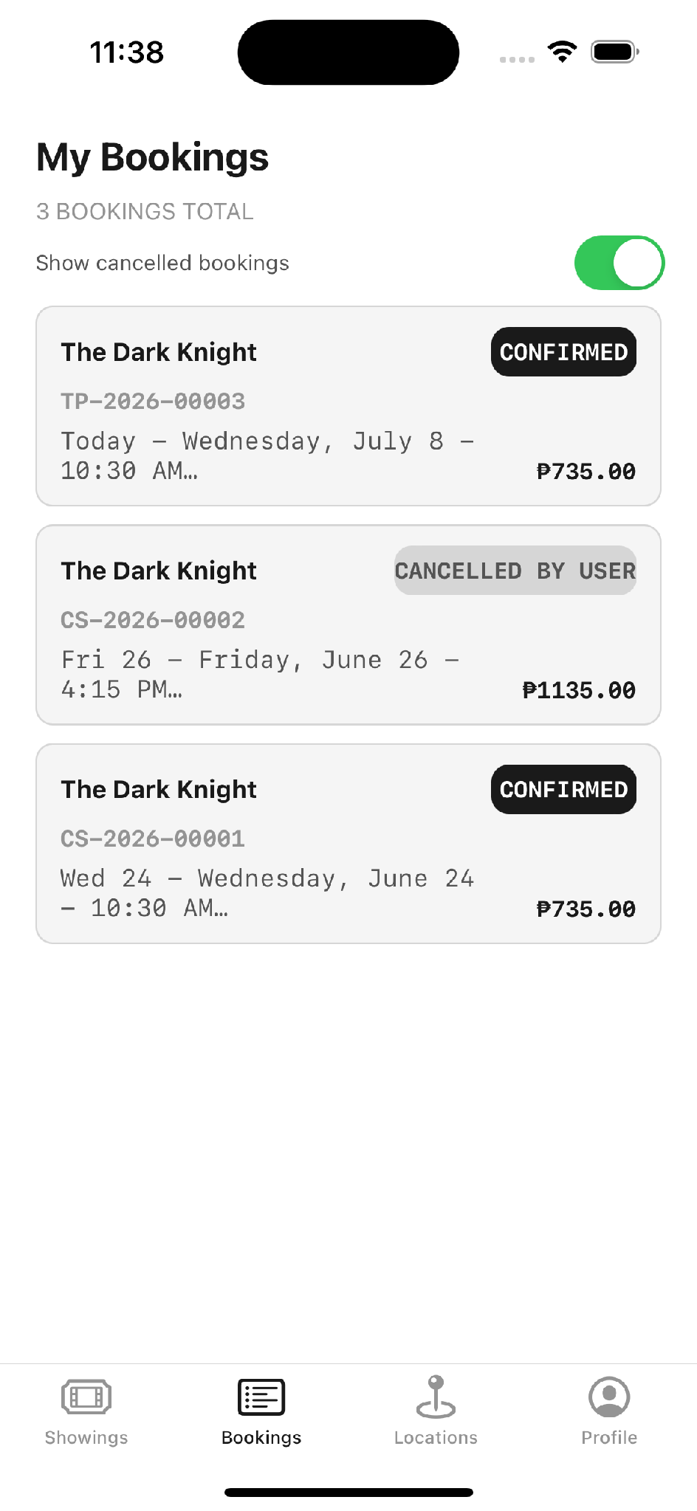
Tab 1 — Showings | Tab 2 — Bookings

 | 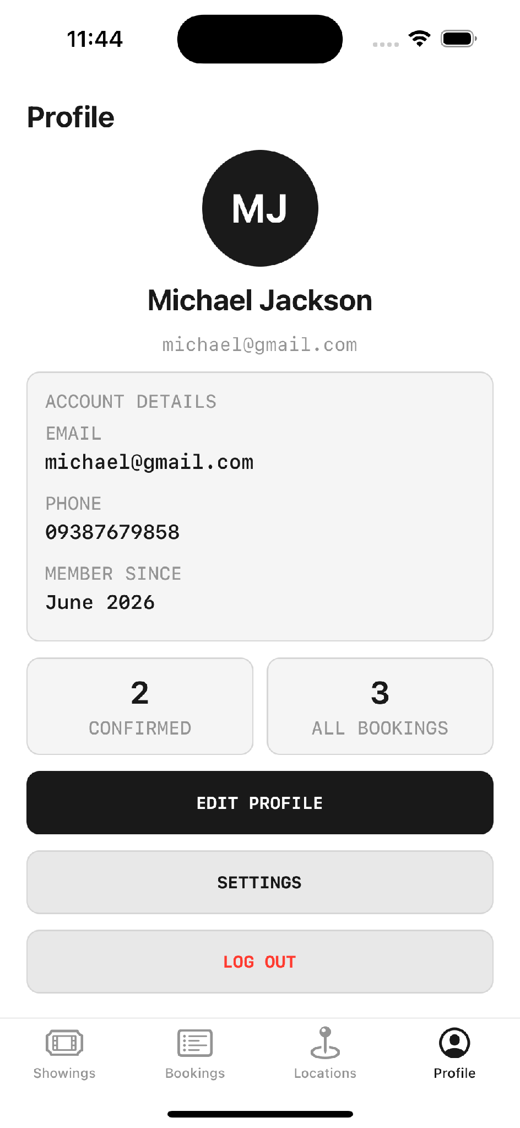
Tab 3 — Locations | Tab 4 — Profile

2.7 Table views
There is a wonderfully simple way to remember the difference between a table view and a collection view, and it needs no improving on. A table view is your Facebook news feed — a single scrolling column of full-width rows. A collection view is your photo gallery — a grid of tiles. Table views are far more common in everyday apps and easier to maintain, so this curriculum concentrates on them and treats collection views as a variation on the same idea.

The two protocols you cannot skip
UITableView — delegate and data source wired in viewDidLoad
class ViewController: UIViewController, UITableViewDelegate, UITableViewDataSource {

@IBOutlet weak var tableView: UITableView!

override func viewDidLoad() {
super.viewDidLoad()
// Without these two lines nothing appears — this is the classic mistake
tableView.delegate = self
tableView.dataSource = self
}

func tableView(_ tableView: UITableView, numberOfRowsInSection section: Int) -> Int {
return 10
}

func tableView(_ tableView: UITableView,
cellForRowAt indexPath: IndexPath) -> UITableViewCell {
let cell = UITableViewCell(style: .default, reuseIdentifier: "cell")
cell.textLabel?.text = "Row \(indexPath.row)"
return cell
}
}

SWIFTUI EQUIVALENT Cell reuse, prepareForReuse and reuse identifiers are all handled for you.
// List replaces UITableView. There is no delegate and no data source —
// the collection you pass in IS the data source, and rows are just views.
struct MovieListView: View {
let movies: [Movie]

var body: some View {
List(movies, id: \.title) { movie in
HStack {
Text(movie.title)
Spacer()
Text(movie.genre).foregroundStyle(.secondary)
}
}
}
}

WHAT DISAPPEARS HERE Three of this module's hardest-won lessons simply evaporate in SwiftUI: registering and dequeuing reusable cells, assigning delegate and dataSource, and clearing stale content in prepareForReuse. That is not an argument against learning them — the empty-table-view bug caused by a missing dataSource is one of the most common in UIKit, and you will meet it in any existing codebase — but it is honest to show viewers how much ceremony the newer framework removes.

DELEGATE vs DATA SOURCE Data source supplies the content — how many rows, and what goes in each. Delegate handles interaction — what happens when a row is tapped. Set both in viewDidLoad, because that is where initialisation belongs. Forget them and the table renders empty with no error.

Reusable custom cells in the real app
[ON SCREEN — XCODE] Open CustomViews/Cells/MovieTableViewCell.swift.
TicketPlease — a reusable cell built with stack views
import UIKit

// module 2 reusable movie cell
// table view uses this for the movies screen
final class MovieTableViewCell: UITableViewCell {
static let reuseIdentifier = "MovieTableViewCell"

private let card = CardView()
private let posterView = PosterPlaceholderView()
private let titleLabel = UILabel()
private let detailLabel = UILabel()
private let ratingLabel = UILabel()

override func prepareForReuse() {
super.prepareForReuse()
posterView.loadPoster(from: nil) // clear stale images on reuse
}

private func configureViews() {
let bottomRow = UIStackView(arrangedSubviews: [durationLabel, UIView(), bookLabel])
bottomRow.axis = .horizontal
bottomRow.alignment = .center
// ... constraints against the card
}
}

PRODUCTION DETAIL WORTH SHOWING prepareForReuse is the method beginners miss. Cells are recycled as you scroll, so an old poster can appear briefly in a new row. Clearing the image on reuse is what stops that flicker.

2.8 Alerts, gestures, text fields and scroll views
UIAlertController and UITapGestureRecognizer
// Alert with an action
let alert = UIAlertController(title: "Save",
message: "Booking confirmed",
preferredStyle: .alert)
alert.addAction(UIAlertAction(title: "OK", style: .default))
present(alert, animated: true)

// Tap gesture
let tap = UITapGestureRecognizer(target: self, action: #selector(handleTap))
view.addGestureRecognizer(tap)

CUSTOM ALERTS UIAlertController is deliberately generic — you cannot restyle it. If the design calls for a branded dialog with a logo or artwork, the standard approach is to build a separate view controller with a transparent background and present it modally. It behaves identically from the user's point of view.

✎ PRACTICE EXERCISE Responsive layout and your first table view
Brief. Two independent tasks that together exercise everything in this topic: stack-based layout that survives changing screen sizes, and a table view driven by real data. Keeping both in one project — the table view reached from a button on the calculator — is a good way to practise navigation at the same time.
Your tasks
1. Rework the calculator from Topic 1 so its rows and keypad are built from horizontal and vertical UIStackViews rather than free-floating buttons.
2. Add constraints to the outermost stack against the safe area, and run the layout on at least three device sizes — a small iPhone, a large iPhone, and an iPad.
3. Create a second screen containing a UITableView, reached by a button, inside a navigation controller.
4. Define a simple struct model and a dummy array of a few items, each with an image and a couple of detail fields.
5. Build a reusable custom cell that shows the image alongside its details, and populate the table from the array via the data source.
6. Set the table's delegate and dataSource in viewDidLoad, and confirm the rows appear.
You have succeeded when
✓ The calculator looks correct — not stretched or clipped — on every device size you test.
✓ The table view scrolls and each row shows its image and detail text.
✓ All layout logic lives in stacks and constraints; no view is positioned by a hard-coded frame.
Stretch goal. Make the cell's image scale proportionally on iPad instead of staying its iPhone size — a deliberately tricky constraint problem, and exactly the kind of finishing-pass detail that rewards building the working flow first and polishing the layout last.

A REALISTIC EXPECTATION Expect the constraints half of this exercise to be the frustrating part, and expect the image not to scale correctly on the first attempt — an image that stays iPhone-sized on an iPad is one of the most common outcomes. That is normal. The productive strategy is the one this topic keeps returning to: get the flow working first, treat constraints as a finishing pass, and constrain the stack rather than each individual view.

Module 3 — Intermediate Swift and Concurrency
TOPIC 3 Closures, escaping vs non-escaping, generics, protocol-oriented programming, map/filter/reduce, the Result type, error propagation, ARC and retain cycles, GCD, async/await and actors — the language features that separate code that merely works from code that scales and stays responsive.

3.1 Overview
This is the shortest topic in the curriculum but the most conceptually demanding. It covers the language features that separate code that works from code that scales — and, critically, the concurrency model that keeps the interface responsive.

Closures
A closure is a self-contained block of code you can pass around like a value. If you wrote a computed property in the Module 2 view model, you have already written one.
Swift — closures
// A closure stored in a variable
let add: (Int, Int) -> Int = { a, b in
return a + b
}
print(add(3, 4)) // 7

// In TicketPlease — a callback closure on the seat map
var onSeatTapped: ((String) -> Void)?

Escaping vs non-escaping
 | Non-escaping (default) | @escaping
Timing | Runs and finishes inside the function | Outlives the function call
Style | Synchronous | Asynchronous
Used for | Immediate work | Network calls, image loading, completion handlers
Why it matters | Simple, no retain risk | Prevents the UI freezing while waiting

THE PRACTICAL POINT If you do the work synchronously the interface freezes, which is exactly what you are trying to avoid. Most real work — fetching, decoding, loading images — is asynchronous and escaping.

map, filter and reduce
Swift — the three functional operators used constantly in view models
let numbers = [1, 2, 3, 4, 5]

let doubled = numbers.map { $0 * 2 } // [2, 4, 6, 8, 10]
let evens = numbers.filter { $0 % 2 == 0 } // [2, 4]
let total = numbers.reduce(0, +) // 15

COMMON MISCONCEPTION
The myth: map was described as "finding the specific number you need", and filter as the same thing but more specific.
The reality: map does not search — it transforms. It applies a closure to every element and returns a new collection of the same length. filter selects a subset that satisfies a condition, returning a shorter collection. reduce collapses a collection into one value. Searching is a fourth, separate operation: first(where:). Getting this distinction right matters, because the three are used constantly and are easy to confuse when first learned.

Operation | Does | Input → output
map | Transforms every element | [1,2,3] → [2,4,6] — same length
filter | Keeps elements matching a condition | [1,2,3,4] → [2,4] — shorter
reduce | Collapses to a single value | [1,2,3] → 6 — one value
first(where:) | Finds the first match | [1,2,3] → 2 — one optional element
compactMap | Transforms, discarding nils | ["1","a"] → [1] — shorter
flatMap | Transforms and flattens nesting | [[1,2],[3]] → [1,2,3]

[ON SCREEN — XCODE] Show the real usage from MoviesViewModel — filter, then sorted, chained.
TicketPlease — functional operators doing production work
// TicketPlease — filter and sort chained in the view model
let matchingMovies = movies.filter { movie in
searchText.isEmpty || movie.title.localizedCaseInsensitiveContains(searchText)
}

return matchingMovies.sorted { first, second in
ratingSummary(for: first).effectiveRating > ratingSummary(for: second).effectiveRating
}

// And flatMap + compactMap building the cinema filter list
let cinemas = movieShowings.flatMap(\.allTimes).map(\.time.cinema)
return Dictionary(grouping: cinemas, by: \.id)
.compactMap { $0.value.first }
.sorted { $0.id < $1.id }
.map(\.name)

The Result type and error propagation
Swift — Result models success and failure in one type
func fetchUser(completion: (Result<String, Error>) -> Void) {
// ... on success
completion(.success("Ava"))
}

fetchUser { result in
switch result {
case .success(let name):
print("Fetched \(name)")
case .failure(let error):
print("Failed: \(error)")
}
}

Memory management: strong, weak and unowned
ARC counts references. A strong reference keeps an object alive. A weak reference does not, so the object can be released when nothing else needs it. A retain cycle happens when two objects hold each other strongly and neither can ever be freed — a leak.
Reference | Behaviour | Optional? | When to use
strong | Keeps the object alive. The default. | No | Normal ownership
weak | Does not keep it alive; automatically set to nil when deallocated | Yes — always | The safe default for breaking cycles
unowned | Does not keep it alive and is NOT nilled out. Accessing it after deallocation crashes. | No | Only when the reference is guaranteed to outlive the holder

COMMON MISCONCEPTION
The myth: unowned was described as a reference that "just stays in memory" because it is neither strong nor weak.
The reality: unowned does not retain the object and does not keep it in memory. The real difference from weak is that unowned is non-optional and is never automatically set to nil — so if the object is deallocated and you then access the reference, the app crashes. Use weak by default; reach for unowned only when you can guarantee the referenced object outlives the one holding it.
Source: developer.apple.com — Automatic Reference Counting · avanderlee.com/swift/weak-self

THE HABIT TO BUILD One habit prevents the majority of retain cycles: whenever you write a closure that captures self, mark it [weak self] by default and only drop the weak when you have a specific reason to. It costs nothing when it is unnecessary and saves a whole category of leaks when it is not.

[ON SCREEN — XCODE] Open Persistence/Notifications/LocalNotificationService.swift and highlight [weak self].
TicketPlease — the weak-self rule applied in production
// TicketPlease — [weak self] inside an escaping closure
func scheduleReminders(for booking: Booking) {
guard settingsStore.settings.bookingRemindersEnabled else { return }
requestAuthorizationIfNeeded { [weak self] granted in
guard granted else { return }
self?.addReminderRequests(for: booking)
}
}

Concurrency: GCD and async/await
Mechanism | What it does
Background thread | Long work — fetching data, downloading images or large files
Main thread | All UI updates, without exception
Operation queue | Queued work where task two must wait for task one
async / await | The modern Swift replacement for nested completion handlers
Actors | Thread-safe protection of shared mutable state

Swift — GCD and async/await side by side
// Grand Central Dispatch — the older pattern
DispatchQueue.global(qos: .background).async {
let image = downloadImage()
DispatchQueue.main.async {
imageView.image = image // UI updates must return to the main thread
}
}

// Swift concurrency — the modern pattern
func fetchData() async -> String {
return "data"
}

Task {
let data = await fetchData()
print(data)
}

THE ONE RULE Background threads do the waiting. The main thread does the drawing. Update the UI from a background thread and you get undefined behaviour and crashes.

3.2 From idea to plan — the design workflow
This topic is also the natural place to introduce something that is not a language feature at all but is the professional habit underneath every real project: you do not start by writing code. You start by deciding what the app is, mapping how it behaves, and sketching what it looks like — and only then do you open Xcode. The four-step workflow below is worth stating plainly on camera, because it is the difference between building with a plan and building by guesswork.
- Requirements. List every feature you want, without filtering. Requirements are allowed to be messy and they will grow — the point is to get them out of your head and onto the page.
- Flowchart. Turn those requirements into decision paths. Rectangles are processes, diamonds are decisions, and the branches are where the real thinking happens.
- Wireframe. Sketch what each screen looks like and where each control sits. It should be rough — the goal is placement, not beauty. Draw.io or Figma both work well.
- Build. Now, finally, write code — against something concrete to follow rather than an idea you are inventing as you type.
WHY THE FLOWCHART REALLY MATTERS The reason to draw a flowchart is not neatness — it is defect prevention. When an app is tested, every path through it gets walked, including the failure paths a developer forgets. If every scenario has already been mapped in the flowchart, there is nothing left to discover in testing that you did not already account for. The branches you draw up front are the bugs you do not ship. A worked example of exactly this diagram, for the reference application, appears in Chapter 8.

Consider how this played out for the reference app. It began as a single sentence — a cinema ticket-booking app: browse films, pick a schedule, choose seats, see the price, confirm a reservation. That sentence expanded into a feature list — movie list, movie details, showtimes, seat selection, booking summary, confirmation, a bookings history, cancellation, and validation alerts — which became a flowchart, which became a wireframe, which became the 137-file app used throughout this guide. The list barely changed along the way, with one telling exception: an early review noticed there was no profile screen, and adding accounts turned out to unlock roughly a third of everything else the app could do. A single gap on a requirements list, caught before any code was written, reshaped the whole product.
✎ PRACTICE EXERCISE Design your own app on paper
Brief. Before writing a line of code, take an app idea of your own from a vague sentence to a buildable plan. This is a design exercise, not a coding one — the entire deliverable is the three artefacts that come before Xcode.
Your tasks
1. Choose a small app idea with genuine screens and decisions — a booking app, a to-do app with reminders, a personal-goals tracker. Avoid anything trivial enough to fit on one screen.
2. Write a complete requirements list. Do not stop at the obvious features; include the account, the empty states, and the error cases.
3. Draw a flowchart covering the main journey and, crucially, its failure branches — not signed in, nothing selected, invalid input.
4. Wireframe every screen roughly, deciding only what goes where. Use Draw.io, Figma, or paper.
5. Decide your architecture up front: which screens get a view model, and what data each one needs.
6. Optionally, find a free mock API online that could supply the app's data later.
You have succeeded when
✓ Every screen in your wireframe traces back to a requirement on your list.
✓ Your flowchart shows at least three decision points, each with both outcomes drawn.
✓ You could hand the three artefacts to another developer and they could start building without asking you what the app is.
Stretch goal. Redraw one busy area of your flowchart as a separate sub-flow with its own start and end, the way a large real diagram is decomposed. Cramming every branch onto one canvas is the most common flowchart mistake, and splitting it is the fix.

Module 4 — Networking
TOPIC 4 Networking fundamentals, URLSession, HTTP methods, Codable, encoding and decoding JSON, CodingKeys, API-client architecture, environment configs, headers and tokens, retry logic, async image loading, and dependency managers — everything an app needs to talk to a server safely.

4.1 Overview
Networking is how an app talks to a server over HTTP — in practice, always the encrypted HTTPS. URLSession is Apple's built-in API for it, and an important point to establish early is that no third-party library is required to do networking properly. Everything in this topic is native, and the reference application makes real network calls without a single external dependency.

A GET request
URLSession — the shape every GET request follows
guard let url = URL(string: "https://api.example.com/movies") else { return }

let task = URLSession.shared.dataTask(with: url) { data, response, error in
if let error = error {
print("Request failed: \(error)")
return
}

// Always check the response before trusting the data
guard let httpResponse = response as? HTTPURLResponse,
(200...299).contains(httpResponse.statusCode) else {
return
}

// guard is the safety net — no data means log and exit, not crash
guard let data = data else {
print("No data returned")
return
}

// decode here
}
task.resume()

WHY guard IS EVERYWHERE guard is the networking equivalent of the optionals lesson from Module 1. A successful response can still arrive with an empty body or malformed JSON. guard turns that from a crash into a log line and an early return.

Status codes worth knowing
COMMON MISCONCEPTION
The myth: HTTP error codes were referred to a few times as "402".
The reality: 402 Payment Required is reserved and almost never seen in practice. The codes that actually matter when checking a response are listed below. The pattern to teach is the range check — (200...299).contains(statusCode) — rather than memorising individual numbers.

Code | Meaning | Typical cause
200 OK | Success | The normal case
201 Created | Success, resource created | A successful POST
400 Bad Request | The server rejected the request | Malformed body or parameters
401 Unauthorized | Not authenticated | Missing or expired token
403 Forbidden | Authenticated but not permitted | Insufficient rights
404 Not Found | No such resource | Wrong URL or deleted record
429 Too Many Requests | Rate limited | Too many calls — back off and retry
500 Internal Server Error | The server failed | Not your bug, but you must handle it

HTTP methods
Method | Purpose | In practice
GET | Fetch data. Nothing is sent. | The most common call you will write
POST | Send data and receive a response | Login — send credentials, receive a bearer token
PUT | Update existing data | Often handled server-side
DELETE | Remove data | Often handled server-side

A POST request with headers
URLSession — note dataTask(with: request), not dataTask(with: url)
guard let url = URL(string: "https://api.example.com/login") else { return }

var request = URLRequest(url: url)
request.httpMethod = "POST"
request.setValue("application/json", forHTTPHeaderField: "Content-Type")
request.setValue("Bearer \(token)", forHTTPHeaderField: "Authorization")

let body: [String: Any] = ["name": "John", "age": 25]
request.httpBody = try? JSONSerialization.data(withJSONObject: body)

URLSession.shared.dataTask(with: request) { data, response, error in
// handle response
}.resume()

EASY TO MISS There are two dataTask overloads. A plain GET can pass a URL directly. Anything needing headers, a body or a method must build a URLRequest first and pass that instead.

Codable and CodingKeys
Codable is what maps JSON onto your model. Mark the struct Codable and the decoding is automatic. The complication is naming: Swift uses camelCase, but plenty of backends use snake_case. CodingKeys bridges the two without compromising your Swift naming.
Swift — Codable with CodingKeys
struct UserModel: Codable {
let id: Int
let username: String

// Maps Swift camelCase onto the backend's snake_case
private enum CodingKeys: String, CodingKey {
case id
case username = "user_name"
}
}

let user = try JSONDecoder().decode(UserModel.self, from: data)

[ON SCREEN — XCODE] Open Persistence/Reviews/TMDBReviewAPIClient.swift — the real network layer in the app.
TicketPlease — every Module 4 concept in one file: async/await, headers, status checking, Codable, CodingKeys
// module 4 get request for tmdb movie reviews
final class TMDBReviewAPIClient: OnlineReviewFetching {
private let session: URLSession
private let tokenProvider: () -> String?

func fetchReviews(movieID: Int) async throws -> [OnlineReview] {
guard let token = tokenProvider() else {
throw OnlineReviewError.missingConfiguration
}
guard let url = URL(
string: "https://api.themoviedb.org/3/movie/\(movieID)/reviews?language=en-US&page=1"
) else {
throw OnlineReviewError.invalidResponse
}

var request = URLRequest(url: url)
request.httpMethod = "GET"
request.setValue("Bearer \(token)", forHTTPHeaderField: "Authorization")
request.setValue("application/json", forHTTPHeaderField: "accept")

let (data, response) = try await session.data(for: request)
guard let httpResponse = response as? HTTPURLResponse,
(200...299).contains(httpResponse.statusCode) else {
throw OnlineReviewError.invalidResponse
}
let responseDTO = try JSONDecoder().decode(TMDBReviewResponseDTO.self, from: data)
return responseDTO.results.map(\.onlineReview)
}
}

private struct TMDBReviewDTO: Decodable {
let author: String
let authorDetails: TMDBAuthorDetailsDTO
let createdAt: String

private enum CodingKeys: String, CodingKey {
case author
case authorDetails = "author_details" // TMDB sends snake_case
case createdAt = "created_at"
}
}

[ON SCREEN — IPHONE] Show the Online reviews tab loading from TMDB, next to the app's own reviews.
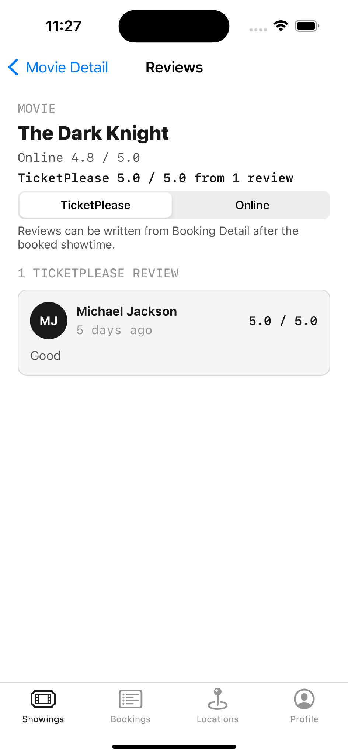 | 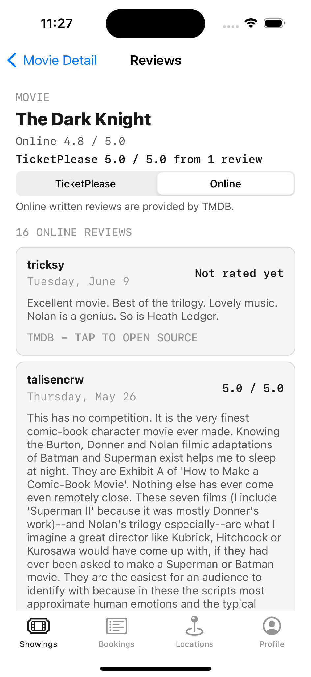
TicketPlease reviews — local JSON | Online reviews — live TMDB API

API client architecture
Rather than repeat the URLSession boilerplate in every screen, you centralise it in one reusable client using generics, so it can decode any Codable model.
A generic, reusable API client — one function for every endpoint
final class APIClient {
static let shared = APIClient()

func fetch<T: Decodable>(_ type: T.Type, from url: URL) async throws -> T {
let (data, response) = try await URLSession.shared.data(from: url)

guard let httpResponse = response as? HTTPURLResponse,
(200...299).contains(httpResponse.statusCode) else {
throw APIError.badResponse
}

return try JSONDecoder().decode(T.self, from: data)
}
}

SWIFTUI EQUIVALENT .task replaces viewDidLoad + Task { } and handles cancellation for you.
// The networking layer is unchanged — URLSession and Codable are not UIKit APIs.
// What changes is how the view triggers and displays it.
struct MovieListView: View {
@State private var movies: [Movie] = []
@State private var isLoading = false

var body: some View {
List(movies, id: \.title) { movie in
Text(movie.title)
}
.overlay { if isLoading { ProgressView() } }
.task { // runs on appear, cancels automatically on disappear
isLoading = true
defer { isLoading = false }
movies = (try? await APIClient.shared.fetch([Movie].self, from: url)) ?? []
}
}
}

THE LAYER THAT DOESN'T CHANGE This is a genuinely useful point for the audience. URLSession, Codable, CodingKeys, status checking and async/await are Foundation, not UIKit — every line of Module 4 is identical in a SwiftUI app. The same is true of Module 5's persistence and Module 6's architecture. Only the presentation layer is framework-specific, which is precisely the payoff of the separation Module 6 argues for.

Environments and credentials
Constants — never hard-code a base URL in a view controller
enum Environment {
case development, production

var baseURL: String {
switch self {
case .development: return "https://dev.api.example.com"
case .production: return "https://api.example.com"
}
}
}

CREDENTIAL HYGIENE — SAY THIS ON CAMERA In TicketPlease the TMDB token lives only in the local Xcode scheme as an environment variable. It is not in the source, not in the repository, and not in the documentation. The README states plainly that before any live release the token must be rotated and moved to a backend, because anything shipped inside an iOS app can be extracted from it.

Async image loading
[ON SCREEN — XCODE] Open CustomViews/Common/PosterPlaceholderView.swift.
Async image loading — UIImage is the data, UIImageView is the UI
func loadImage(from url: URL) async -> UIImage? {
guard let (data, _) = try? await URLSession.shared.data(from: url) else {
return nil
}
return UIImage(data: data)
}

THE THREE-TIER FALLBACK IN THE APP TicketPlease serves its ten movie posters through a chain: bundled asset first, then the FileManager cache, then a URLSession download. The app therefore works fully offline, and the network is only a last resort. That is a good pattern to call out for the audience.

Dependency managers
Manager | Status | Setup
CocoaPods | Older, still widely used | sudo gem install cocoapods` → `pod init` → edit Podfile → `pod install
Swift Package Manager | Apple's, recommended | File → Add Package Dependencies in Xcode

AFTER pod install Once you have pods, stop opening the .xcodeproj and open the .xcworkspace instead. Opening the wrong file is a classic early mistake and produces confusing build failures.

VERSION NOTE (2026) This is the most time-sensitive item in the whole series and it should be stated clearly. CocoaPods entered maintenance mode in August 2024 after thirteen years, and its registry becomes permanently read-only on 2 December 2026 — within months of this video's release. The training taught CocoaPods as the primary dependency manager and mentioned Swift Package Manager as the newer alternative; that emphasis should now be reversed. Teach SPM as the default, and present CocoaPods as something you will meet in existing projects and will need to migrate away from. Anyone starting a new project today should not adopt CocoaPods.
Source: blog.cocoapods.org · CocoaPods Support & Maintenance Plans

It is worth highlighting that the reference application ships with zero third-party dependencies — everything is native Apple frameworks. That is a deliberate choice, and a quietly instructive one: it keeps the build simple, avoids the maintenance-mode problem entirely, and demonstrates that the fundamentals were understood rather than delegated to a library. For a learner, building at least one real feature without pulling in a dependency is an excellent way to prove to yourself that you actually understand what the library would have done.
✎ PRACTICE EXERCISE Fetch and decode from a real API
Brief. Connect a screen to live data. Use any free public JSON API — a placeholder API, a weather API, a public-data API — and get its response onto the screen through a clean networking layer rather than a call buried in a view controller.
Your tasks
1. Find a free JSON API and inspect the exact shape of one of its responses.
2. Define a Codable struct that matches that response, using CodingKeys wherever the JSON uses snake_case.
3. Write a small, reusable API client with an async function that fetches and decodes into your model.
4. Check the HTTP status code before trusting the body, and guard every optional so a bad response logs and returns instead of crashing.
5. Call the client from a view model — never directly from the view controller — and display the decoded data in a table view.
6. Test the failure path: point the URL at something that does not exist and confirm the app degrades gracefully rather than crashing.
You have succeeded when
✓ Real data from the network appears in your list.
✓ A deliberately broken URL produces a logged error and an empty or placeholder state, never a crash.
✓ The networking code lives in its own type, and the view controller never sees a URL.
Stretch goal. Add async image loading with a three-tier fallback — bundled placeholder, on-disk cache, then network download — so the screen still shows something sensible with no connection at all.

Module 5 — Data Persistence and Security
TOPIC 5 UserDefaults, FileManager, Core Data, Keychain services and access groups — choosing the right place to keep each kind of data, from a single preference flag to a securely stored password.

5.1 Overview
By this point an app can fetch data. This topic answers the question that immediately follows: where does that data go, and how does it survive the app being closed and reopened? The important lesson is that there is no single answer. iOS deliberately provides several storage mechanisms, and the skill is choosing the one that fits the weight and the sensitivity of each piece of data — a mismatch here is how apps end up either slow or insecure.
[GRAPHIC] Animate this table as a horizontal scale: the lightweight stores enter from the left, the heavier ones from the right, and the Keychain drops in from above as a separate, locked box that sits apart from the scale entirely. The visual metaphor — weight along one axis, security on another — is exactly the mental model the topic is trying to install.
Store | Weight | Use for | Do not use for
UserDefaults | Lightweight | Non-sensitive flags, UI preferences, feature toggles | Passwords, tokens, anything sensitive or large
FileManager | Medium | Documents, images, large JSON files | Highly structured relational data
Core Data | Heavy | Structured data with relationships, offline sync | A single boolean
Keychain | Secure | Passwords, tokens, credentials, sensitive data | General app state

UserDefaults
UserDefaults — key/value storage for small data
let defaults = UserDefaults.standard

// Save — always a value plus a key
defaults.set(true, forKey: "isDarkMode")
defaults.set("Ava", forKey: "username")

// Retrieve — the type must match what you saved
let isDarkMode = defaults.bool(forKey: "isDarkMode")
let username = defaults.string(forKey: "username")

TYPE MISMATCH Save a Bool and read it back as a String and you get an error. A useful naming habit prevents this: prefix boolean keys with 'is' or 'has' — isDarkMode, hasLaunchedBefore — so the key itself reads as a yes/no question and reminds you of the type it holds.

Security — the most important point in this topic
COMMON MISCONCEPTION
The myth: UserDefaults is a safe place to store a password or a token, because on iOS it is 'automatically encrypted' — unlike Android, where you have to encrypt it yourself.
The reality: UserDefaults is NOT encrypted. It writes to a plain, unencrypted .plist file inside the app's container, with no access control. Anyone with filesystem access, a jailbroken device, or an unencrypted device backup can read it in seconds. Passwords, tokens, API keys and any personal data must go in the Keychain, which is encrypted and protected by the operating system. UserDefaults is for non-sensitive preferences only.
Source: appknox.com/blog/ios-insecure-local-storage-guide · ptkd.com/journal/ios-keychain-vs-userdefaults-storing-tokens

HOW TO HANDLE THIS ON CAMERA This is one of the most consequential myths in all of iOS development, so do not skip it and do not soften it — a training series is exactly the right place to put it to rest. The most effective way to teach it is by contrast: state the myth, then show the reference application doing the right thing, which stores passwords in the Keychain and keeps UserDefaults for only the signed-in profile ID and small navigation flags. Seeing the correct implementation immediately after the myth makes the lesson land far harder than the rule stated on its own.

[ON SCREEN — XCODE] Open Persistence/AppPreferences.swift.
TicketPlease — keys held in a private enum so they can never be mistyped
// module 5 userdefaults preferences
// plist handles app settings while userdefaults keeps tiny navigation flags
final class AppPreferences: AppPreferencesManaging {
static let shared = AppPreferences(settingsStore: AppSettingsStore.shared)

private enum Key {
static let hasLaunchedBefore = "hasLaunchedBefore"
static let selectedMovieCategory = "selectedMovieCategory"
static let showCancelledBookings = "showCancelledBookings"
}

private let defaults: UserDefaults

var hasLaunchedBefore: Bool {
get { defaults.bool(forKey: Key.hasLaunchedBefore) }
set { defaults.set(newValue, forKey: Key.hasLaunchedBefore) }
}
}

Storing Codable objects in UserDefaults
You cannot store a model directly — convert to JSON data first
struct User: Codable {
let name: String
let age: Int
}

// Encode the model to JSON before storing
let user = User(name: "Anna", age: 18)
if let encoded = try? JSONEncoder().encode(user) {
UserDefaults.standard.set(encoded, forKey: "user")
}

// Decode it back on retrieval
if let data = UserDefaults.standard.data(forKey: "user"),
let decoded = try? JSONDecoder().decode(User.self, from: data) {
print(decoded.name)
}

FileManager
FileManager — reading and writing files in the Documents directory
func getDocumentsDirectory() -> URL {
FileManager.default.urls(for: .documentDirectory, in: .userDomainMask)[0]
}

// Write
let url = getDocumentsDirectory().appendingPathComponent("message.txt")
try "Hello world".write(to: url, atomically: true, encoding: .utf8)

// Read
let text = try String(contentsOf: url, encoding: .utf8)

[ON SCREEN — XCODE] Open Persistence/Booking/BookingFileRepository.swift — this is how every booking in the app is saved.
TicketPlease — Codable + FileManager as a repository, behind a protocol
// module 5 filemanager repository
// bookings are saved as codable json in the documents directory
final class BookingFileRepository: BookingPersisting {
private let fileURL: URL

init(fileManager: FileManager = .default, fileName: String = "bookings.json") {
let documentsDirectory = fileManager.urls(
for: .documentDirectory, in: .userDomainMask
).first!
fileURL = documentsDirectory.appendingPathComponent(fileName)

let encoder = JSONEncoder()
encoder.outputFormatting = [.prettyPrinted, .sortedKeys]
encoder.dateEncodingStrategy = .iso8601
}

func loadBookings() throws -> [Booking] {
guard reader.exists(at: fileURL) else { return [] }
return try reader.read([Booking].self, from: fileURL)
}

func saveBookings(_ bookings: [Booking]) throws {
try writer.write(bookings, to: fileURL)
}
}

[ON SCREEN — IPHONE] Confirm a booking, then close and reopen the app to show it persisted.
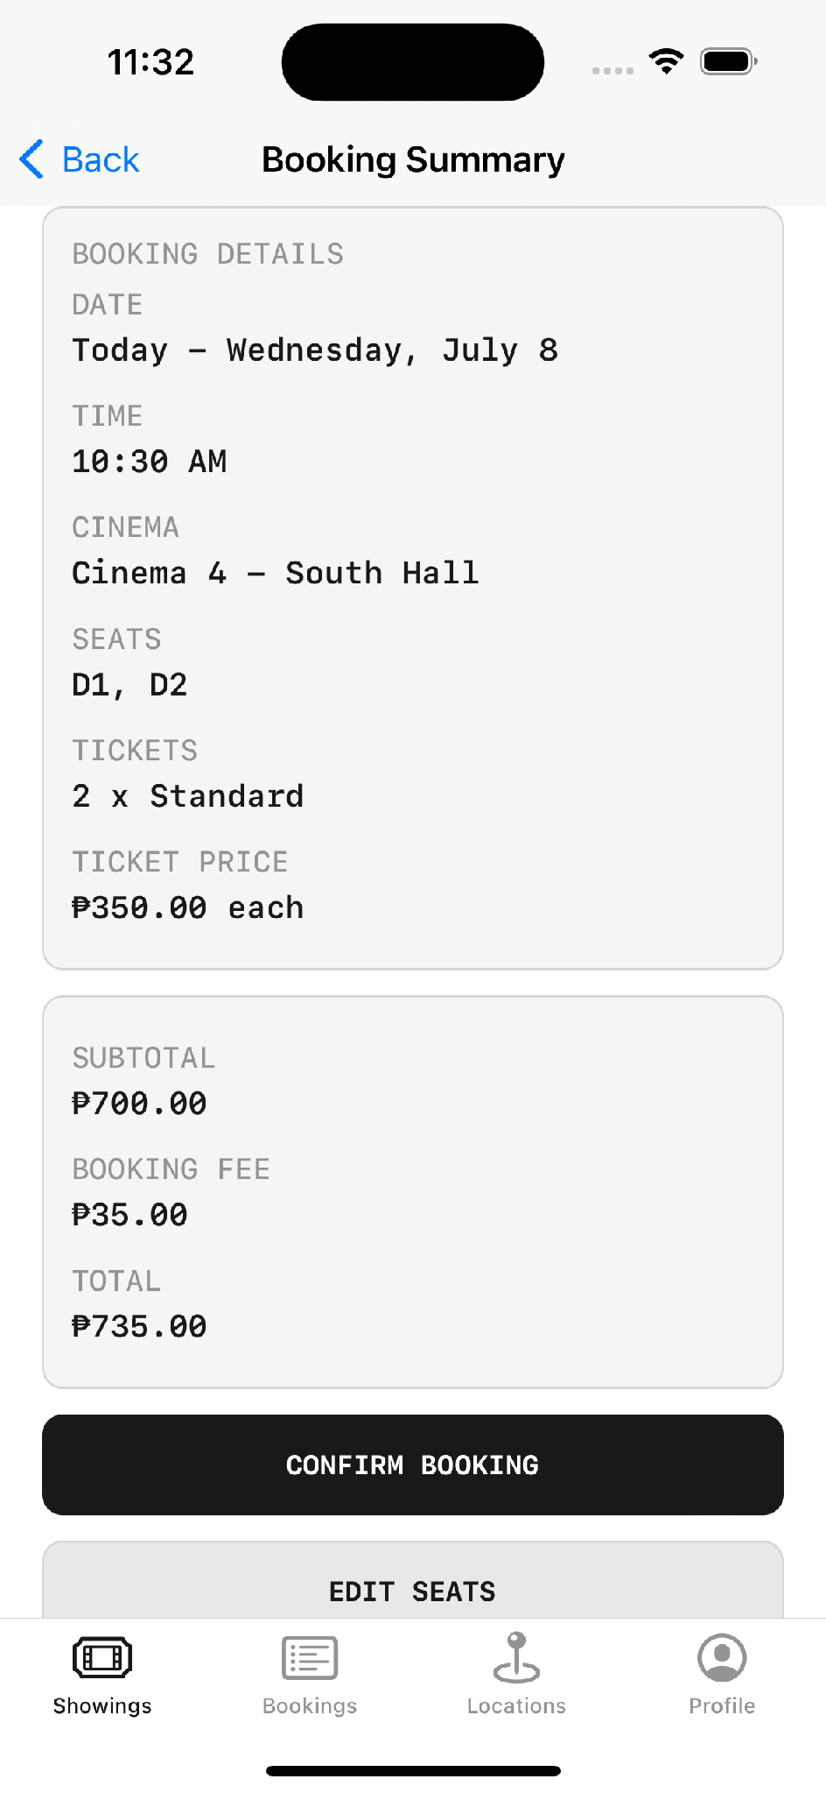
Booking summary | Confirmed — written to bookings.json | Still there after relaunch

Core Data
Core Data is the heavyweight option — a full object graph and persistence framework with entities, attributes and relationships. It is what you reach for when you need real structured data with relationships, or offline content that syncs later.
Core Data — insert, fetch, predicate, delete. Every change ends with context.save()
// Insert
let context = persistentContainer.viewContext
let newUser = UserEntity(context: context)
newUser.name = "John"
newUser.age = 25
try context.save()

// Fetch
let request: NSFetchRequest<UserEntity> = UserEntity.fetchRequest()
let users = try context.fetch(request)

// Filter with a predicate
request.predicate = NSPredicate(format: "age > %d", 25)

// Delete
context.delete(users.first!)
try context.save()

A DELIBERATE DECISION IN THE APP TicketPlease does not use Core Data. Given the data volume, FileManager with Codable JSON was the right fit and far simpler to reason about. Worth saying on camera: knowing when not to reach for the heavyweight tool is part of the skill.

VERSION NOTE (2026) The training did not mention SwiftData, and viewers will ask about it. SwiftData is Apple's newer persistence framework, introduced with iOS 17 and built on top of Core Data. It replaces the .xcdatamodeld file and NSManagedObject subclasses with plain Swift classes and macros, and it is designed to pair with SwiftUI. It is not a straight upgrade, though: as of 2026 it is still slower than Core Data, lacks some capabilities such as grouping and fetched results controllers, and its API has continued to shift between releases. The fair summary for the video — SwiftData for a new SwiftUI-first app targeting iOS 17 or later; Core Data for existing projects, older deployment targets, or where you need fine-grained control.
Source: fatbobman.com/en/posts/why-i-am-still-thinking-about-core-data-in-2026 · distantjob.com/blog/core-data-vs-swiftdata

Keychain services
Passwords and tokens do not belong in a JSON file. The Keychain is encrypted and protected by the operating system, and it is the correct place for credentials.
[ON SCREEN — XCODE] Open Persistence/Profile/KeychainPasswordStore.swift.
TicketPlease — the real Keychain implementation, matching the taught pattern exactly
import Security

// module 5 keychain password storage
// passwords are saved outside the profile json file
final class KeychainPasswordStore: PasswordStoring {
private let service: String

func savePassword(_ password: String, accountID: UUID) throws {
try deletePassword(accountID: accountID)
guard let data = password.data(using: .utf8) else {
throw AuthenticationError.storageFailed
}

let query: [String: Any] = [
kSecClass as String: kSecClassGenericPassword,
kSecAttrService as String: service,
kSecAttrAccount as String: accountID.uuidString,
kSecAttrAccessible as String: kSecAttrAccessibleAfterFirstUnlockThisDeviceOnly,
kSecValueData as String: data
]
guard SecItemAdd(query as CFDictionary, nil) == errSecSuccess else {
throw AuthenticationError.storageFailed
}
}

func password(accountID: UUID) throws -> String? {
let query: [String: Any] = [
kSecClass as String: kSecClassGenericPassword,
kSecAttrService as String: service,
kSecAttrAccount as String: accountID.uuidString,
kSecReturnData as String: true,
kSecMatchLimit as String: kSecMatchLimitOne
]

var result: CFTypeRef?
let status = SecItemCopyMatching(query as CFDictionary, &result)
if status == errSecItemNotFound { return nil }
guard status == errSecSuccess,
let data = result as? Data,
let password = String(data: data, encoding: .utf8) else {
throw AuthenticationError.storageFailed
}
return password
}
}

Operation | Keychain function
Create | SecItemAdd
Read | SecItemCopyMatching
Update | SecItemUpdate
Delete | SecItemDelete

FORMAT CONSISTENCY Save as UTF-8 and read as UTF-8. Whatever encoding you write with, you must read with. Mismatched formats are a common and confusing source of Keychain failures.

The accessibility attribute — a detail worth one slide
Look again at the query in that code: kSecAttrAccessibleAfterFirstUnlockThisDeviceOnly. That single constant decides when the item can be read and whether it can escape the device, and it is the part of a Keychain implementation most often left on its default.
Constant | Readable when | Use for
kSecAttrAccessibleWhenUnlocked | Only while the device is unlocked | Foreground-only apps — the most restrictive common choice
kSecAttrAccessibleAfterFirstUnlock | After the first unlock following a restart | Items a background task must reach
`...ThisDeviceOnly` variants | Same as above, but never migrate to a new device or backup | Anything that must not leak through an iCloud or iTunes backup

WHY THE APP CHOSE THIS ONE The guidance is to pick the most restrictive class the app can still function under, and to prefer a ThisDeviceOnly variant wherever practical so credentials cannot be lifted out of a device backup. TicketPlease uses AfterFirstUnlockThisDeviceOnly: the password stays on the one device it was created on and never travels in a backup. If the app were strictly foreground-only, WhenUnlockedThisDeviceOnly would be tighter still — a good discussion point on camera rather than a hard rule.

[ON SCREEN — IPHONE] Create an account, log out, log back in — the password never touches profiles.json.
 | 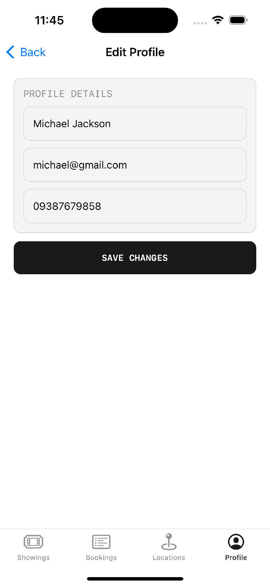
Account screen | Profile editing

The complete persistence map in TicketPlease
Data | Where it lives | Mechanism
Bookings | Documents/bookings.json | FileManager + Codable
Profiles | Documents/profiles.json | FileManager + Codable
Reviews | Documents/reviews.json | FileManager + Codable
Settings | CineSeatSettings.plist | Plist repository
Seat layouts | `SeatLayouts.plist` (editable copy) | Plist repository
Session & preferences | UserDefaults | Key/value
Passwords | iOS Keychain | OS-encrypted
Posters | Caches/PosterCache | URLSession + cache
Bundled content | 7 LocalContent JSON files | DTO → mapper → model

✎ PRACTICE EXERCISE Persist and secure your app's data
Brief. Give the app from the earlier exercises a memory. Add local persistence so data survives relaunch, and store one sensitive value the correct way. This is where an app stops being a demo and starts being usable.
Your tasks
1. Add a simple account or profile to your app, captured on a form.
2. Persist the app's main data — bookings, tasks, whatever your app manages — as Codable JSON in the Documents directory via FileManager.
3. Store one small preference (a toggle, a last-selected filter) in UserDefaults, using an 'is'/'has' key name.
4. Store the account password in the Keychain — never in UserDefaults or the JSON file — matching the encoding on save and read.
5. Confirm persistence by relaunching: the data and the signed-in state should still be there.
6. Draw up your own version of the persistence map table for your app: every kind of data, where it lives, and by which mechanism.
You have succeeded when
✓ Closing and reopening the app preserves its data and session.
✓ The password is in the Keychain and appears nowhere in any readable file.
✓ You can justify, for each piece of data, why it lives where it does.
Stretch goal. Choose the most restrictive Keychain accessibility class your app can tolerate — a ThisDeviceOnly variant, so the credential can never be lifted out of an iCloud or iTunes backup — and be ready to explain why you picked it.

Module 6 — Architecture Patterns and Dependency Injection
TOPIC 6 MVC, MVVM, Clean Architecture layers, dependency injection, the singleton, protocol-based DI and the factory pattern — the structural decisions that keep a growing codebase readable, testable and safe to change.

6.1 Overview
This topic revisits architecture with the benefit of having built something to apply it to. A piece of history makes the motivation vivid: there was a time when a very long file was taken as a sign of a skilled developer, and ten thousand lines in a single view controller was worn almost as a badge of honour. That is emphatically no longer how good code is judged.
The modern goal is the opposite of length. Files should be readable, responsibilities should be cleanly separated, and when something breaks you should know instantly where to look for it. The measure of quality is not how much code sits in one place, but how quickly a stranger could find the one piece they need to change. Length is not skill; navigability is.

The problem MVC creates
MASSIVE VIEW CONTROLLER In plain MVC everything ends up in the controller — data loading, parsing, business logic and UI updates. The controller grows without limit. This is such a well-known failure mode that it has a name, and it is the reason MVVM exists.

Clean Architecture
[GRAPHIC] Animate the three layers stacking upward, with arrows pointing inward only.
Layer | Contains | In TicketPlease
Presentation | Views and view models | View/` and `ViewModel/
Domain | Protocol contracts and use cases — framework-independent | Domain/
Data | Models, repositories, API clients, stores | Models/` and `Persistence/

THE KEY RULE Dependencies point inward only. The domain layer knows nothing about UIKit, nothing about URLSession, and nothing about where data is stored. That is what makes it testable.

6.2 Dependency injection
There are three patterns worth knowing here, and the reference application uses all three — each in the place it genuinely belongs, which is itself part of the lesson. The point is not to pick a favourite but to recognise which situation calls for which.

Singleton
Singleton — one instance, accessible globally
final class NetworkManager {
static let shared = NetworkManager()
private init() { }
}

// UserDefaults.standard is itself a singleton — you have used the pattern already

Protocol-based injection — the recommended approach
This is the professional standard, and it is worth stating why. In serious production codebases, every significant service tends to sit behind a protocol, so its behaviour can be swapped anywhere without touching the code that uses it. The consumer depends only on the contract — the protocol — and never on the concrete class that happens to fulfil it today. That single discipline is what makes a codebase both testable and safe to change, as the testing chapter later demonstrates in full.
Protocol-based DI — the pattern that makes code testable
protocol NetworkService {
func fetch()
}

final class APIService: NetworkService {
func fetch() { print("API fetch") }
}

final class MockService: NetworkService {
func fetch() { print("Mock fetch") } // same contract, different behaviour
}

final class HomeViewController: UIViewController {
private let service: NetworkService

// The dependency is handed in, not created inside
init(service: NetworkService) {
self.service = service
super.init(nibName: nil, bundle: nil)
}
}

[ON SCREEN — XCODE] Open Domain/DependencyProtocols.swift — the real contracts in the app.
TicketPlease — every dependency expressed as a protocol
// module 6 domain contracts
// protocol-based di keeps viewmodels away from concrete stores and api clients
protocol MovieFetching {
func fetchMovies() -> [Movie]
}

protocol EventFetching {
func fetchEvents(category: EventCategory) -> [EventListing]
}

protocol AppPreferencesManaging: AnyObject {
var hasLaunchedBefore: Bool { get set }
var selectedMovieCategory: MovieCategory { get set }
var showCancelledBookings: Bool { get set }
}

protocol BookingManaging: AnyObject {
var bookings: [Booking] { get }

@discardableResult
func addBooking(from draft: BookingDraft, owner: UserProfile) -> Booking

@discardableResult
func cancelBooking(id: String, reason: BookingCancellationReason) -> Bool

func bookedSeats(for draft: BookingDraft) -> Set<String>
}

Factory pattern — the composition root
The factory is where the concrete types are finally chosen. Everything else in the app receives protocols; one file decides what actually gets injected. In TicketPlease that file is AppFactory, and it is the single place a dependency can be swapped for the whole app.
[ON SCREEN — XCODE] Open Design/AppFactory.swift.
TicketPlease — the composition root wiring the entire application
// module 6 factory pattern
// singleton stays at the composition root while features receive protocols
struct AppDependencies {
let preferences: AppPreferencesManaging
let settingsStore: AppSettingsManaging
let authenticationService: Authenticating
let fetchMoviesUseCase: FetchMoviesUseCase
let fetchOnlineReviewsUseCase: FetchOnlineReviewsUseCase
let confirmBookingUseCase: ConfirmBookingUseCase
let notificationScheduler: BookingNotificationScheduling
// ... every dependency in the app

static var live: AppDependencies {
let settingsStore = AppSettingsStore.shared
let bookingManager = BookingStore.shared
let movieFetcher = LocalMovieContentClient()

return AppDependencies(
preferences: AppPreferences.shared,
settingsStore: settingsStore,
authenticationService: AuthenticationService.shared,
fetchMoviesUseCase: DefaultFetchMoviesUseCase(movieFetcher: movieFetcher),
fetchOnlineReviewsUseCase: DefaultFetchOnlineReviewsUseCase(
onlineReviewFetcher: TMDBReviewAPIClient()
),
confirmBookingUseCase: DefaultConfirmBookingUseCase(
bookingManager: bookingManager
),
notificationScheduler: LocalNotificationService.shared
)
}
}

WHY THIS IS THE PAYOFF Because every screen receives protocols and only AppFactory names concrete types, swapping the local JSON client for a real backend later is a change in one file. Nothing in the presentation layer needs to know it happened. That is the practical value of the whole module.

Custom views as a design layer
[ON SCREEN — XCODE] Open CustomViews/Seating/SeatMapView.swift.
TicketPlease — vertical rows of horizontal seat stacks, with explicit aisle gaps
// module 6 design layer custom view
// this is a custom UIKit seat map using stack views and buttons
final class SeatMapView: UIView {
private let gridStack = UIStackView()
private var layout: SeatLayout?
private var selectedSeats: Set<String> = []

var onSeatTapped: ((String) -> Void)?

func configure(
layout: SeatLayout,
selectedSeats: Set<String>,
isInteractive: Bool = true,
seatStateProvider: ((String, Bool) -> SeatVisualState)? = nil
) {
self.layout = layout
self.selectedSeats = selectedSeats
rebuildGrid()
}
}

[ON SCREEN — IPHONE] Select seats to show the custom view responding to taps, then cut to the same map appearing read-only inside booking detail. The teaching point is that one custom view serves two purposes — interactive in one place, display-only in another — so linger on the fact that it is visibly the same component in both shots.
 | 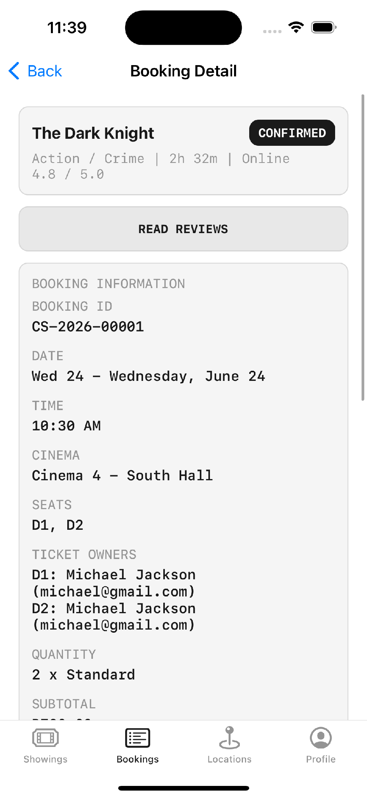
Seat selection — interactive | Booking detail — the same view, read-only

✎ PRACTICE EXERCISE Put your logic behind a protocol
Brief. Take a screen from your app whose view controller currently does everything, and refactor it so its data work sits behind a protocol and is injected rather than hard-wired. The goal is a screen that no longer knows or cares where its data comes from.
Your tasks
1. Pick a screen that currently fetches or loads its own data directly inside the view controller.
2. Move all of that data logic into a view model.
3. Define a protocol describing what the view model needs — for example a fetch method returning your model.
4. Write two conformances to that protocol: the real one, and a mock that returns fixed sample data.
5. Inject the dependency through the initialiser, so the view model receives the protocol and never constructs the concrete type itself.
6. Run the screen once with the real implementation and once with the mock, changing only which one you inject.
You have succeeded when
✓ The view controller contains no data-loading code — only display.
✓ Swapping real data for mock data is a one-line change at the injection point.
✓ Nothing in the view model mentions a concrete store, API client, or URL.
Stretch goal. Add a single composition root — one type, like a factory, that decides which concrete implementations get injected across the whole app — so that swapping a data source later is a change in exactly one file.

Module 7 — Maps, Location, Notifications, Media and Animation
TOPIC 7 MapKit, Core Location, Info.plist permissions, the Apple Push Notification service, the camera and photo pickers, PHPicker, file access, AVFoundation preview, UIView animation, Core Animation and Lottie — the device capabilities that make an app feel genuinely native.

7.1 Overview
The final core topic is a tour of device capabilities — the frameworks that let an app reach beyond its own data and touch the hardware and the operating system underneath it. These are the features that make an app feel native rather than like a website in a frame: it knows where it is, it can send a reminder, it can use the camera, and it moves with intention rather than snapping between states.

MapKit and Core Location are two different things
THE DISTINCTION MapKit is the UI — the map you see, the pins, the callouts. Core Location is the hardware — GPS, heading, geofencing. MapKit uses Core Location. Keeping them separate in your head prevents a lot of confusion.

MapKit or Google Maps?
COMMON MISCONCEPTION
The myth: Trainees were advised more than once to use Google Maps rather than Apple's MapKit, on the grounds that Google Maps is "more developed" and "better".
The reality: This is a trade-off rather than a clear win, and the cost side was not mentioned. MapKit is native, requires no API key, no billing account and no credit card, and is free for native app development. The Google Maps SDK for iOS is pay-as-you-go and requires a billing account with a card on file before it will even issue you an API key. Google's SDK does offer richer place data — full addresses, phone numbers, websites, business types. So: Google Maps if you specifically need that place metadata and accept the billing setup; MapKit for everything else, especially a training project or an app that simply needs to show locations.
Source: developers.google.com/maps/documentation/ios-sdk/usage-and-billing · developer.apple.com — MapKit

WHAT THE APP ACTUALLY DID TicketPlease uses MapKit, not Google Maps — pins, callouts, zoom controls and an Apple Maps hand-off, with zero third-party dependencies and no billing account. For an app that needs to show eight cinemas and a set of event venues, that is the right call, and it is a useful moment to show a real decision being made against advice.

MapKit — region, radius and annotations
import MapKit

let mapView = MKMapView()

// Centre the map on a coordinate with a radius
let coordinate = CLLocationCoordinate2D(latitude: 14.5995, longitude: 120.9842)
let region = MKCoordinateRegion(
center: coordinate,
latitudinalMeters: 1000,
longitudinalMeters: 1000
)
mapView.setRegion(region, animated: true)

// Drop a pin
let annotation = MKPointAnnotation()
annotation.coordinate = coordinate
annotation.title = "Manila"
mapView.addAnnotation(annotation)

SWIFTUI EQUIVALENT MKMapViewDelegate, MKPointAnnotation and manual region maths all disappear.
import MapKit

// iOS 17+ Map API — annotations are views, declared inline
struct CinemaMapView: View {
let cinemas: [Cinema]

var body: some View {
Map {
ForEach(cinemas) { cinema in
Marker(cinema.name, coordinate: cinema.coordinate)
.tint(.blue)
}
}
.mapControls {
MapUserLocationButton()
MapCompass()
}
}
}

[ON SCREEN — XCODE] Open View/CinemaLocationsViewController.swift — the real implementation.
TicketPlease — MKMapViewDelegate driving custom pins and callouts
// TicketPlease — real cinema and venue pins
private let mapView = MKMapView()

annotation.coordinate = CLLocationCoordinate2D(
latitude: item.latitude,
longitude: item.longitude
)
mapView.addAnnotations(annotations)
mapView.setRegion(MKCoordinateRegion(center: center, span: span), animated: false)

extension CinemaLocationsViewController: MKMapViewDelegate {
func mapView(_ mapView: MKMapView, viewFor annotation: MKAnnotation) -> MKAnnotationView? {
// custom pin with a callout that opens Cinema Details
}
}

[ON SCREEN — IPHONE] Pan the map, tap a pin, open the callout, land on Cinema Details.
 | 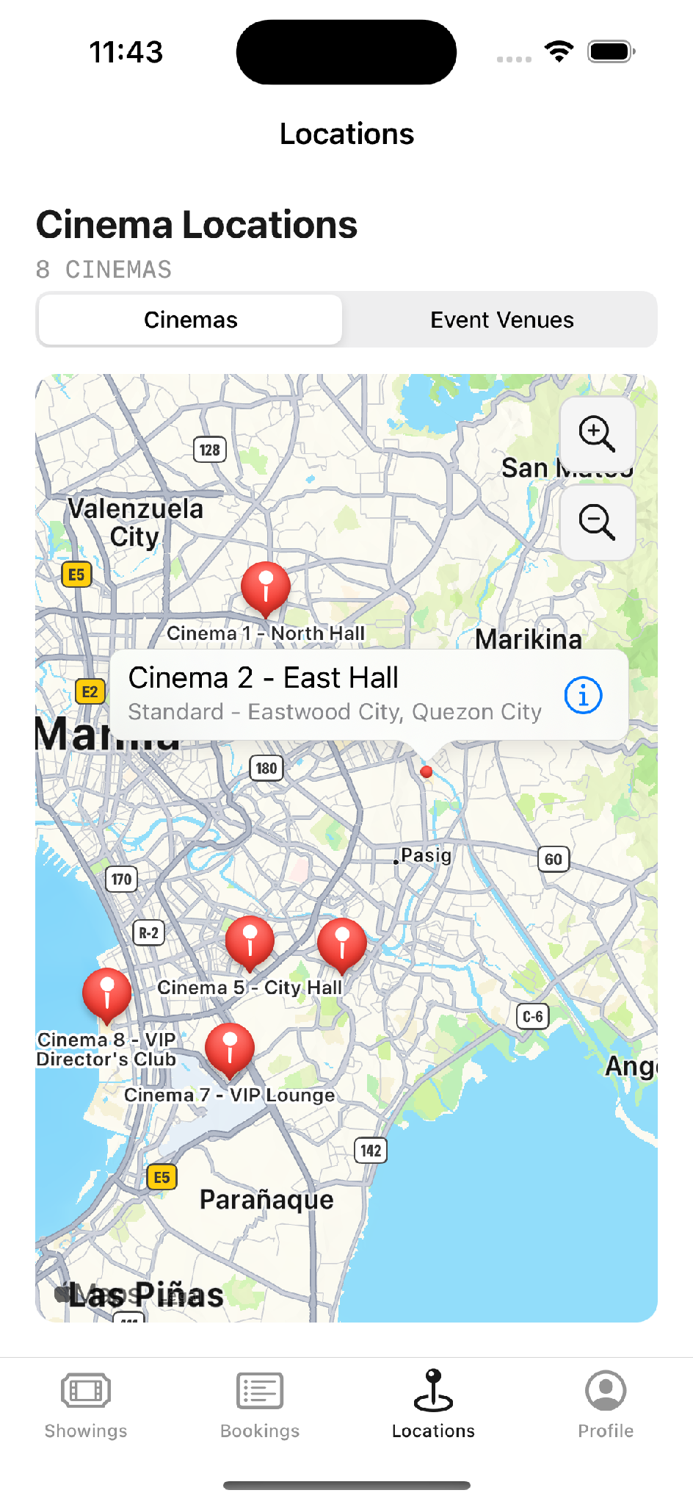 | 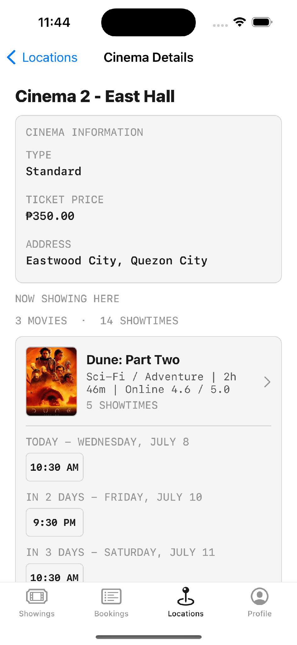
Cinema and venue pins | Tapping a pin opens a callout | Cinema Details with showtimes

Core Location and permissions
Core Location — delegate, accuracy and authorisation request
import CoreLocation

final class LocationManager: NSObject, CLLocationManagerDelegate {
private let manager = CLLocationManager()

override init() {
super.init()
manager.delegate = self
manager.desiredAccuracy = kCLLocationAccuracyBest
manager.requestWhenInUseAuthorization() // must ask the user
}

func locationManager(_ manager: CLLocationManager,
didUpdateLocations locations: [CLLocation]) {
guard let location = locations.first else { return }
print(location.coordinate.latitude, location.coordinate.longitude)
}
}

THE STEP EVERYONE FORGETS Permissions must be declared in Info.plist or the feature simply will not work. No Info.plist entry, no capability — and on top of that, App Store review rejects builds that use a protected capability without a purpose string.

The exact keys, since they must be typed character-for-character:
Info.plist key | Unlocks
NSLocationWhenInUseUsageDescription | Location while the user is actively using the app
NSLocationAlwaysAndWhenInUseUsageDescription | Location including background use
NSCameraUsageDescription | Camera capture
NSPhotoLibraryUsageDescription | Reading from the photo library
NSPhotoLibraryAddUsageDescription | Saving into the photo library
NSMicrophoneUsageDescription | Microphone, including video recording with audio

THE STRING IS USER-FACING Whatever you type as the value is shown verbatim in the system permission alert. Write a plain, specific reason — "Used to show cinemas near you" — not "location". A vague or empty purpose string is both a poor user experience and a common review rejection.

Push notifications
APNs — Apple Push Notification service — is Apple's official push system. Setting it up properly requires enabling the Push Notifications capability, generating APNs keys from a paid Apple Developer account, and uploading them to your server or Firebase Cloud Messaging.
AppDelegate — requesting notification authorisation at launch
import UserNotifications

func application(_ application: UIApplication,
didFinishLaunchingWithOptions options: [...]) -> Bool {

UNUserNotificationCenter.current().delegate = self

UNUserNotificationCenter.current().requestAuthorization(
options: [.alert, .sound, .badge]
) { granted, error in
guard granted else { return }
DispatchQueue.main.async {
application.registerForRemoteNotifications()
}
}
return true
}

WHAT APNs ACTUALLY COSTS APNs charges nothing per message, but it is gated behind the Apple Developer Program at USD 99 per year — and that is only the entry fee. You also need a server to talk to APNs, and the authentication credential has to be maintained: certificate-based setups expire annually and must be regenerated and re-uploaded before they lapse. This is worth stating plainly, because it explains why a training project reaches for local notifications instead.

TicketPlease uses local notifications rather than APNs, because it has no backend. The reminders are scheduled on the device through UserNotifications — no server, no push certificate, no annual fee — and from the user's perspective they are indistinguishable. The important limitation to name: local notifications can only fire on a schedule this device already knows about. Anything driven by an external event — a cancelled screening, a changed showtime, a transferred ticket — genuinely requires APNs.
[ON SCREEN — XCODE] Open Persistence/Notifications/LocalNotificationService.swift.
TicketPlease — local reminders, respecting a user setting and cancelled on booking cancellation
import UserNotifications

// local notification service
// this is local only and does not use remote push notifications
final class LocalNotificationService: BookingNotificationScheduling {
static let shared = LocalNotificationService()

private let center: UNUserNotificationCenter
private let settingsStore: AppSettingsManaging

func scheduleReminders(for booking: Booking) {
guard settingsStore.settings.bookingRemindersEnabled else { return }
requestAuthorizationIfNeeded { [weak self] granted in
guard granted else { return }
self?.addReminderRequests(for: booking)
}
}

func cancelReminders(for bookingID: String) {
let identifiers = AppConstants.Notifications.reminderLeadTimes.map {
reminderIdentifier(bookingID: bookingID, leadTime: $0)
}
center.removePendingNotificationRequests(withIdentifiers: identifiers)
}
}

[ON SCREEN — IPHONE] Trigger the Developer Mode five-second test notification and capture both surfaces.
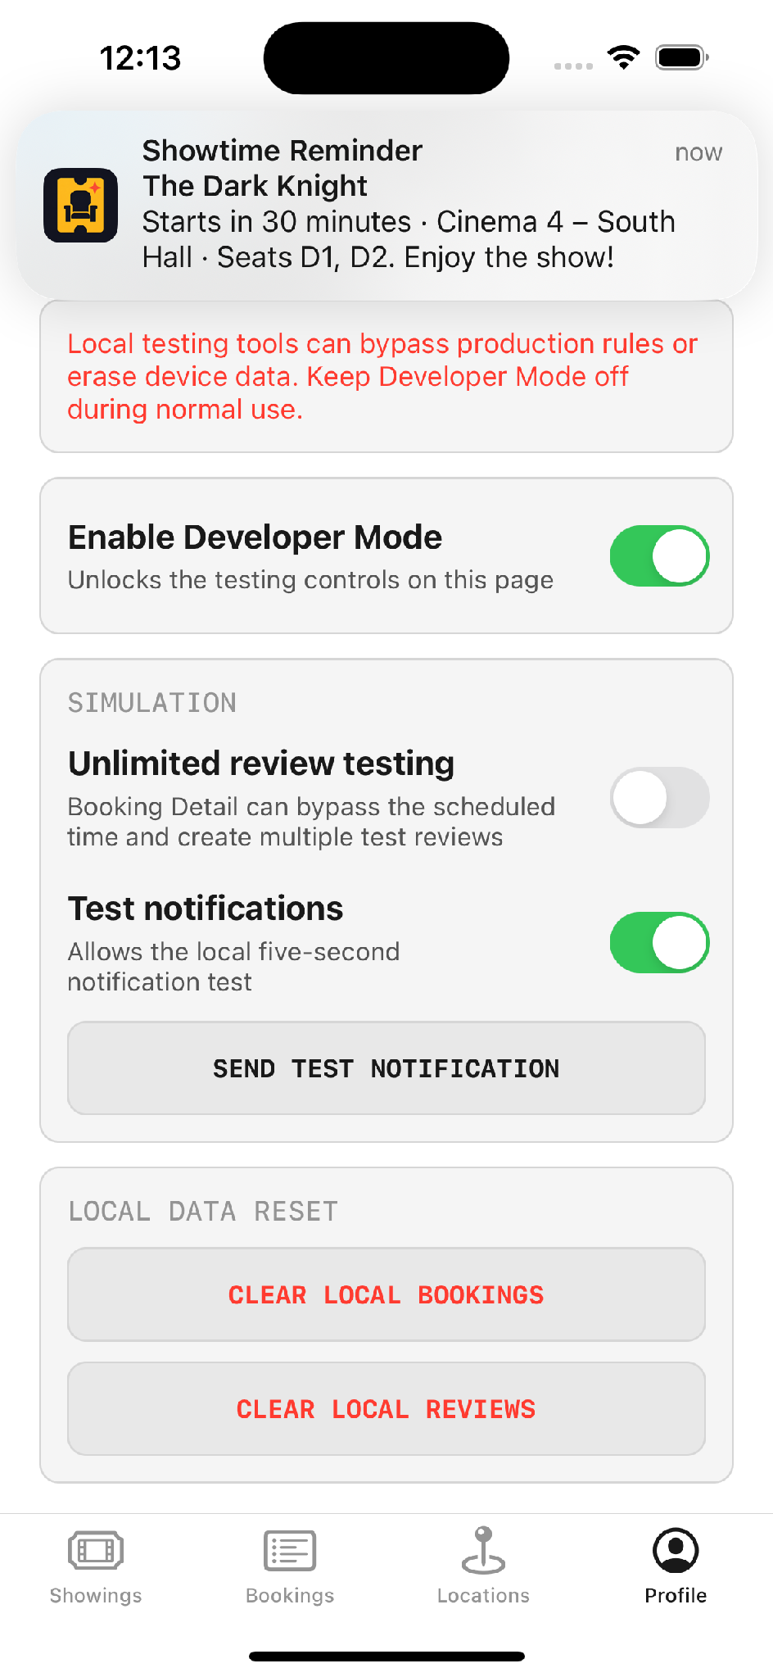 | 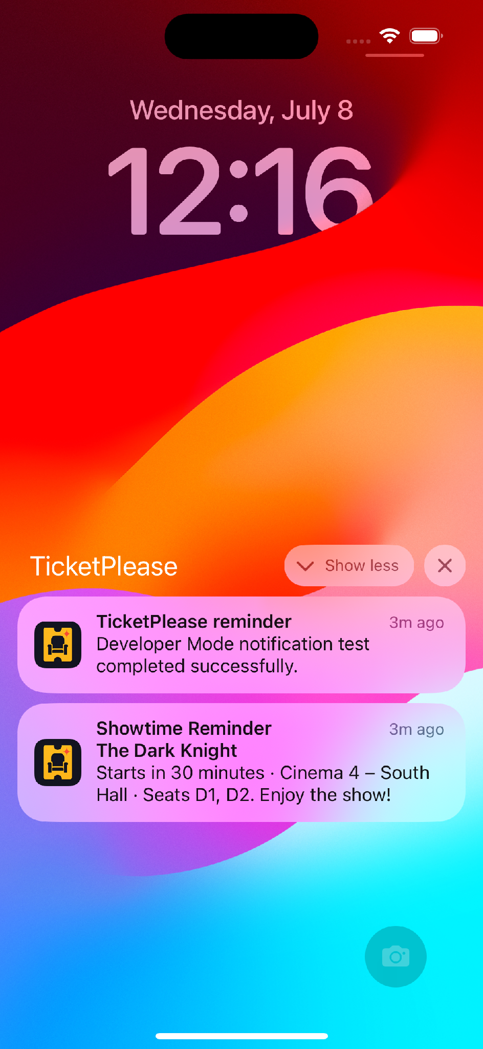
Delivered as a banner | And on the lock screen

Camera and photos
API | Status | Use
UIImagePickerController | Soft-deprecated since iOS 14 | Camera capture — still the only option for this
PHPickerViewController | Modern, iOS 14+ | Photo library, supports multiple selection
UIDocumentPickerViewController | Current | Files app — PDFs, images, arbitrary documents
AVCaptureSession | AVFoundation | Custom camera preview, video and audio

PHPicker — 'PH' is Photos, not Philippines
// Modern photo picking
import PhotosUI

var configuration = PHPickerConfiguration()
configuration.selectionLimit = 1

let picker = PHPickerViewController(configuration: configuration)
picker.delegate = self
present(picker, animated: true)

VERSION NOTE (2026) The relationship between these two APIs is more definite than they are sometimes given credit for. Apple soft-deprecated UIImagePickerController in iOS 14 — the API is annotated "will be removed in a future release, use PHPicker" — so it should no longer be presented as simply the easier of two equal options. PHPicker is the correct choice for the photo library: it runs out of process, needs no photo-library permission prompt at all for user-selected items, and supports multiple selection. The important caveat, which is easy to get wrong: PHPicker cannot take a photo. For camera capture, UIImagePickerController remains the API you use. Most real apps therefore use both — PHPicker for the library, UIImagePickerController for the camera.
Source: developer.apple.com — PHPickerViewController · appcoda.com/phpicker

Animation
UIView animation — duration is what creates the effect; 0 is an instant jump
// Simple fade
UIView.animate(withDuration: 0.3) {
view.alpha = 0
}

// Spring animation
UIView.animate(
withDuration: 0.5,
delay: 0,
usingSpringWithDamping: 0.6,
initialSpringVelocity: 0.5
) {
view.transform = CGAffineTransform(scaleX: 1.1, y: 1.1)
}

SWIFTUI EQUIVALENT SwiftUI interpolates between states; you never write the intermediate frames.
// Animate the state change, not the view
@State private var isVisible = true

var body: some View {
PosterView()
.opacity(isVisible ? 0 : 1)
.animation(.easeInOut(duration: 0.3), value: isVisible)

Button("Toggle") {
withAnimation(.spring(duration: 0.5, bounce: 0.4)) {
isVisible.toggle()
}
}
}

Tool | When to use
UIView.animate | Fades, moves, scales — the everyday case
Core Animation | More complex, layered animation
Lottie | Designer-authored animations — the modern successor to GIFs

✎ PRACTICE EXERCISE Add a native capability
Brief. Give your app one feature that reaches beyond its own data into the device or the operating system. Any one of the options below is enough — the goal is to practise the permission handshake and the framework, not to build all of them.
Your tasks
1. Pick one capability: a map with pins (MapKit + Core Location), a local reminder (UserNotifications), or photo selection (PHPickerViewController).
2. Add the exact Info.plist purpose string the capability requires, written as a clear, specific sentence a user would accept.
3. Request the permission at the right moment and handle refusal gracefully — the feature should degrade, never crash, when access is denied.
4. Wire the capability into a real screen: real coordinates on the map, a reminder tied to a real date, a picked image shown in an image view.
5. Add one small animation — a fade or a spring — so a state change feels intentional rather than abrupt.
6. Test the denied-permission path deliberately by refusing access in Settings and relaunching.
You have succeeded when
✓ The permission prompt appears with your own purpose string.
✓ Denying permission leaves the app usable, with a sensible fallback, and no crash.
✓ The feature works end to end with real data on a simulator or device.
Stretch goal. If you built the map, make a pin's callout deep-link into another screen; if you built notifications, schedule the reminder for a specific future time and confirm it fires while the app is backgrounded.

Chapter 8 — Case Study: Building a Complete App

8.1 From idea to finished app
The seven topics each teach a capability in isolation. This chapter shows what it looks like when they are assembled into one coherent product, using the reference application as a fully worked example. The value here is less in any single line of code and more in the shape of the process — the disciplined path from a one-sentence idea to a running app — because that path is reusable for any app a viewer might go on to build. It is deliberately the same four-step workflow introduced in Topic 3, now followed all the way through to a finished result.
[GRAPHIC] Animate the four-step workflow as a left-to-right flow, each stage lighting up as the narrator reaches it. This is the backbone of the chapter, so keep it on screen as a recurring lower-third or chapter marker that advances through Requirements → Flowchart → Wireframe → Build as each section begins.
Step | Output | What it produces
1. Requirements | A plain feature list | Agreement on what the app must do, before any design
2. Flowchart | Every path and decision mapped | The failure branches found before they become bugs
3. Wireframe | Every screen sketched roughly | Placement decided cheaply, on paper, not in code
4. Build | 137 Swift files across 11 milestones | The finished, testable application

8.2 Step 1 — Requirements
The first artefact is a plain feature list: no diagrams, no design, simply what the app has to do. It is worth showing on screen precisely because it is unglamorous — a list a non-developer could have written — and yet everything downstream traces back to it. The list below is the reference application's, and the right-hand column shows what each line eventually became once it had been through the flowchart, the wireframe and the build.
Feature | Became
Movie list | Movies tab, later generalised into the Showings hub
Movie details | Movie Detail screen with synopsis, rating and poster
Show times / schedule | Nested one-week schedules with multiple showtimes per cinema
Seat selection | Cinema-specific seat maps with varied layouts per venue
Booking summary | Summary screen with item, venue, schedule, seats and total
Booking confirmation | Confirmation screen with a TP booking ID
Profile of bookings | Bookings tab with local history and booking detail
Cancel booking | Cancellation with seat release and reminder cancellation
Validation alerts | Alerts for no showtime selected, no seat selected, and ownership rules

THE FEEDBACK THAT CHANGED THE APP One item was missing from the original list, and it was caught during an early review: there was no profile screen. Adding accounts turned out to be the change that made everything else meaningful — bookings could now be owned, tickets could be shared by email, and reviews could be gated on whether the user actually held a ticket. A single line of feedback on a requirements list ended up producing roughly a third of the finished app. It is the clearest possible argument for writing requirements down where someone else can read and question them, rather than holding them in your head.

8.3 Step 2 — Flowchart
The requirements then become a flowchart: rectangles for processes, diamonds for decisions, and arrows for every route between them. The diagram below maps the reference application's booking flow exactly as the finished app implements it, which makes it both a design artefact and an accurate map of the shipped product. Read it as the spine of the whole app — almost every screen shown in this guide appears somewhere on it.
[GRAPHIC] This is the single strongest asset in the entire guide. Animate it path by path: first trace the happy path — start, browse, select, confirm, done — in one bright colour so the core journey reads clearly, then reveal each failure and side branch in a second colour so the viewer sees how much of real app design is the handling of things going wrong. A full-resolution vector PNG is supplied alongside this document for compositing.
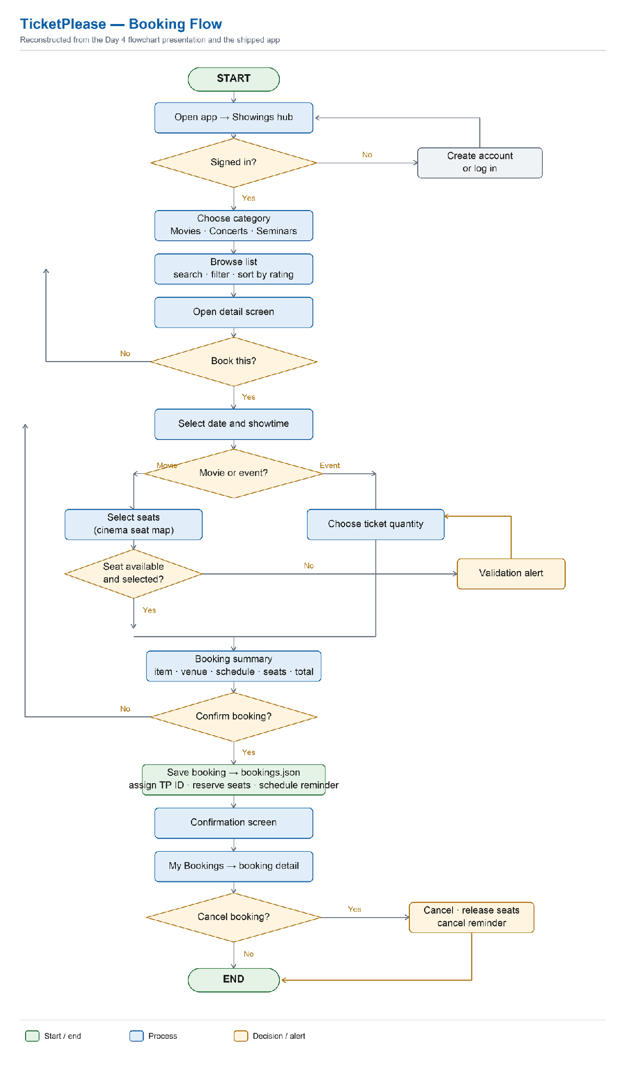
The reference application's booking flow — every path and decision, including the failure branches
WHAT TO POINT OUT ON THIS DIAGRAM The most instructive parts of a flowchart are the branches that are not the happy path. 'Seat available and selected?' leading to a validation alert. 'Signed in?' routing off to account creation and back again. The cancel path that both releases the seats and cancels the pending reminder. Those side branches are precisely where bugs breed, and drawing them before any code exists is the entire argument for making a flowchart in the first place — you are designing the error handling deliberately, rather than discovering it by accident later.

THE PROFESSIONAL REASON TO DO THIS The justification is not academic tidiness. When an app is tested, every path through it gets walked, including the awkward ones. If every scenario is already mapped on the flowchart, testing turns up nothing that was not already anticipated and handled. A flowchart is defect prevention, not documentation theatre — and that is the framing worth putting on camera.

8.4 Step 3 — Wireframe
The wireframe comes next: a rough sketch of every screen, deciding only what goes where. It is deliberately unpolished, because its job is placement, not appearance — chasing pixel-perfect visuals at this stage wastes effort on decisions that will change once real content lands. The table below traces each planned screen through to the screen that actually shipped, so the distance between the sketch and the result is visible.
# | Planned wireframe screen | Shipped as
1 | Movie list | Movies list with search, category filter and rating sort
2 | Movie details | Movie Detail with poster, synopsis, rating and reviews
3 | Seat selection | Interactive seat map, layout varying by cinema
4 | Price / total | Folded into the booking summary rather than a separate screen
5 | Confirm booking | Confirmation screen with TP booking ID
6 | My bookings | Bookings tab with local history
7 | Booking detail / cancel | Booking Detail with seat map, sharing and cancellation
8 | Info / how to use | Dropped — replaced by Settings and the in-app changelog
+ | Profile (added after feedback) | Account creation, login, editing and restored sessions

WHAT CHANGED BETWEEN PLAN AND BUILD Two deviations are worth narrating, because they show a plan working as intended rather than failing. The 'how to use' tab was cut — it existed only to fill a fourth tab in the minimum version, and the Settings screen made it redundant. And a payment step was scoped out on purpose: an early plan mentioned a simulated payment, and the considered decision was to ship no payment at all rather than a fake one that could mislead. Both are healthy examples of a plan being a starting point to argue with, not a contract to execute blindly.

8.5 The build timeline
The reference application was built in eleven dated milestones across roughly three weeks. This same table returns in Chapter 10, because it is not only a build history — it is also the app's change list, and it is the concrete example the documentation chapter is built around. Read down the right-hand column and you also have a second view of the whole curriculum, since each milestone leaned on a different topic.
Milestone | What shipped | Topic exercised
01 | Initial UIKit / MVVM setup — project scaffold, storyboard tabs, outlets, actions, table views, first flows | UIKit + MVVM foundations
02 | Booking, profile and persistence — movie detail, seat selection, accounts, Keychain, FileManager JSON | Persistence & security
03 | Movie data, posters, cinema rules and seating — ratings, offline posters, 8 cinemas, varied seat layouts | Networking + custom views
04 | Schedules, notifications and architecture cleanup — nested schedules, local reminders, Clean Architecture, DI, AppFactory, DTOs | Clean Architecture + DI
05 | Plist settings, seat database and UI polish — Settings menu, plist seat layouts, shared UI constants, first unit tests | Plist persistence + design tokens
06 | Showings expansion, maps, sharing and launch cleanup — Movies renamed to Showings, MapKit pins, ticket sharing | MapKit + content architecture
07 | Interactive cinema pins and showtime shortcuts — callouts, grouped showtimes, Apple Maps hand-off | MapKit interaction + navigation
08 | Concert / seminar booking and feature separation — separate models and screens, quantity booking, app icon, tests | Feature modularisation + reuse
09 | TicketPlease brand and review system — TP booking IDs, account-owned reviews, eligibility rules, Developer Mode | Data ownership + release prep
10 | Booking-owned and online reviews — read-only showing reviews, TMDB separation, local-only token | API integration + credential hygiene
11 | Rating and showing text consistency — shared formatters, standardised 4.7 / 5.0, normalised durations | Consistency & polish

8.6 The complete booking flow
[ON SCREEN — IPHONE] Record the whole booking flow as one continuous, unbroken take on a device, then cut to these five stills as chapter markers. The single-take version proves the flow is real and fast; the stills let the narrator pause on each step. Five taps carry the user from browsing to a confirmed, locally-persisted ticket.
The payoff of the whole chapter is this: five taps from browsing a film to holding a confirmed, locally-persisted ticket with its own TP booking ID. Every step on screen is a concept from an earlier topic doing real work — the detail screen from Topic 2, the data from Topics 4 and 5, the architecture from Topic 6.
 | 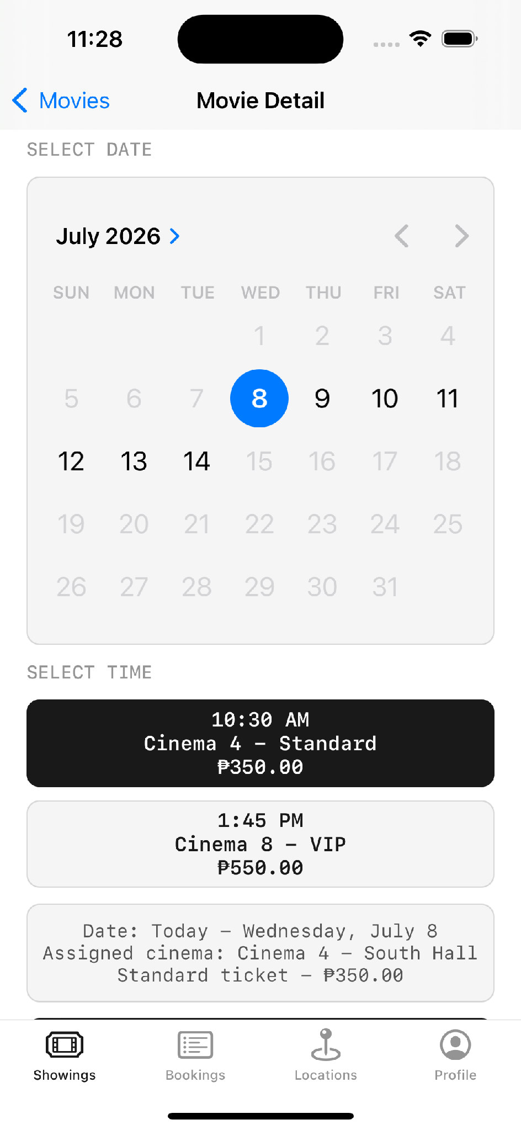
1. Detail | 2. Schedule | 3. Seats

4. Summary | 5. Confirmed

8.7 Two booking modes, one engine
One design detail deserves its own moment, because it is the reuse the whole architecture argument was building toward. Movies book by seat; concerts and seminars book by quantity. Rather than two separate booking systems, the app runs a single reservation core with two different front-ends bolted onto it — a concrete, on-screen illustration of exactly the reuse that Clean Architecture and protocol-based dependency injection are supposed to make possible.
 | 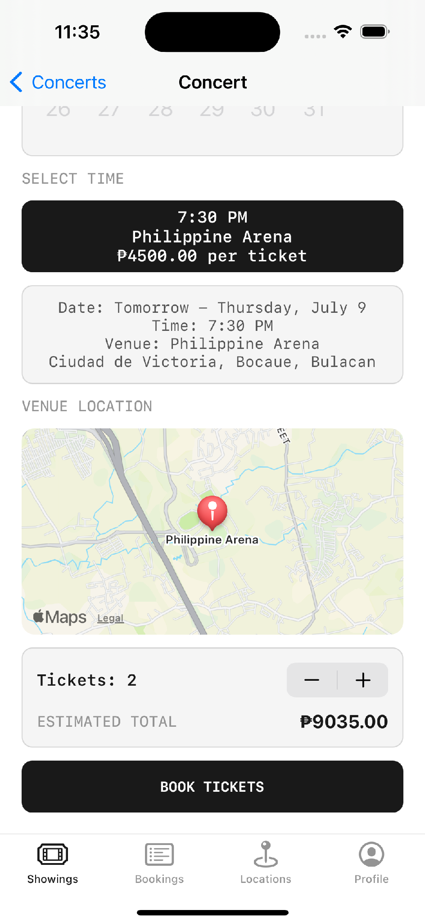
Movies — cinema-specific seat map | Concerts & seminars — quantity

Movies — cinema-specific seat map | Concerts & seminars — quantity

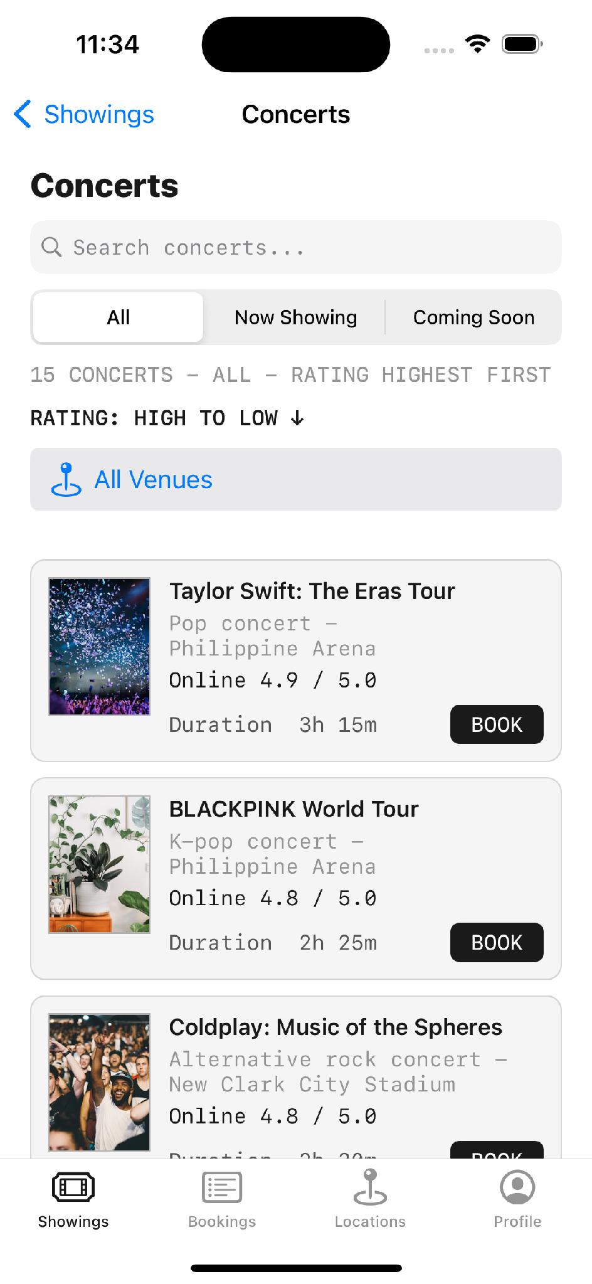 | 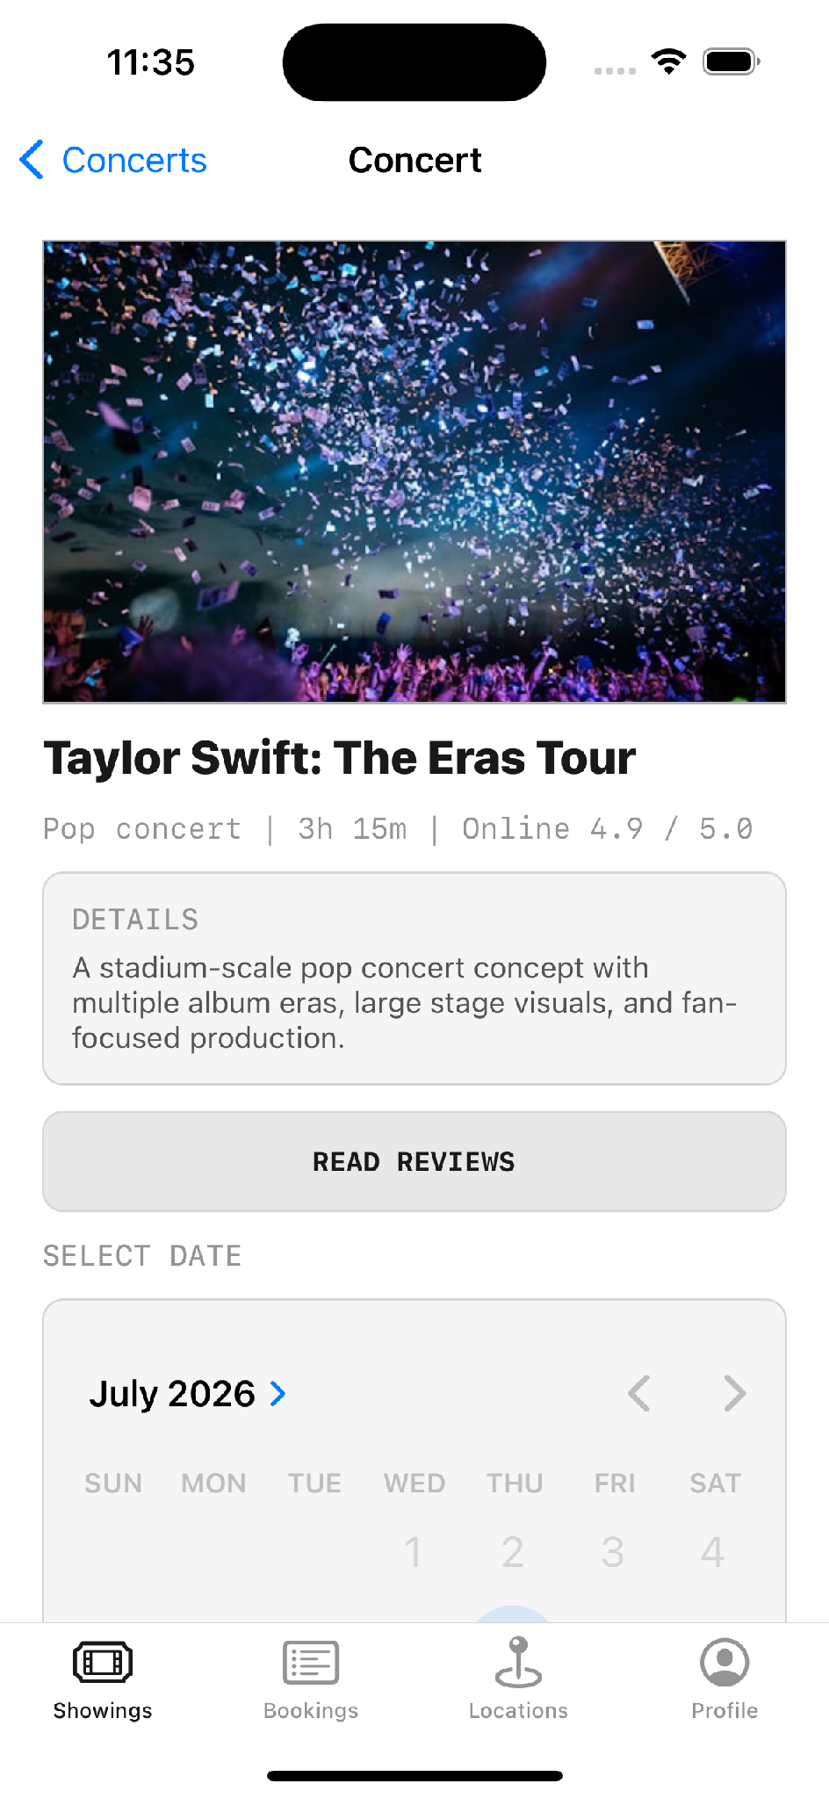 | 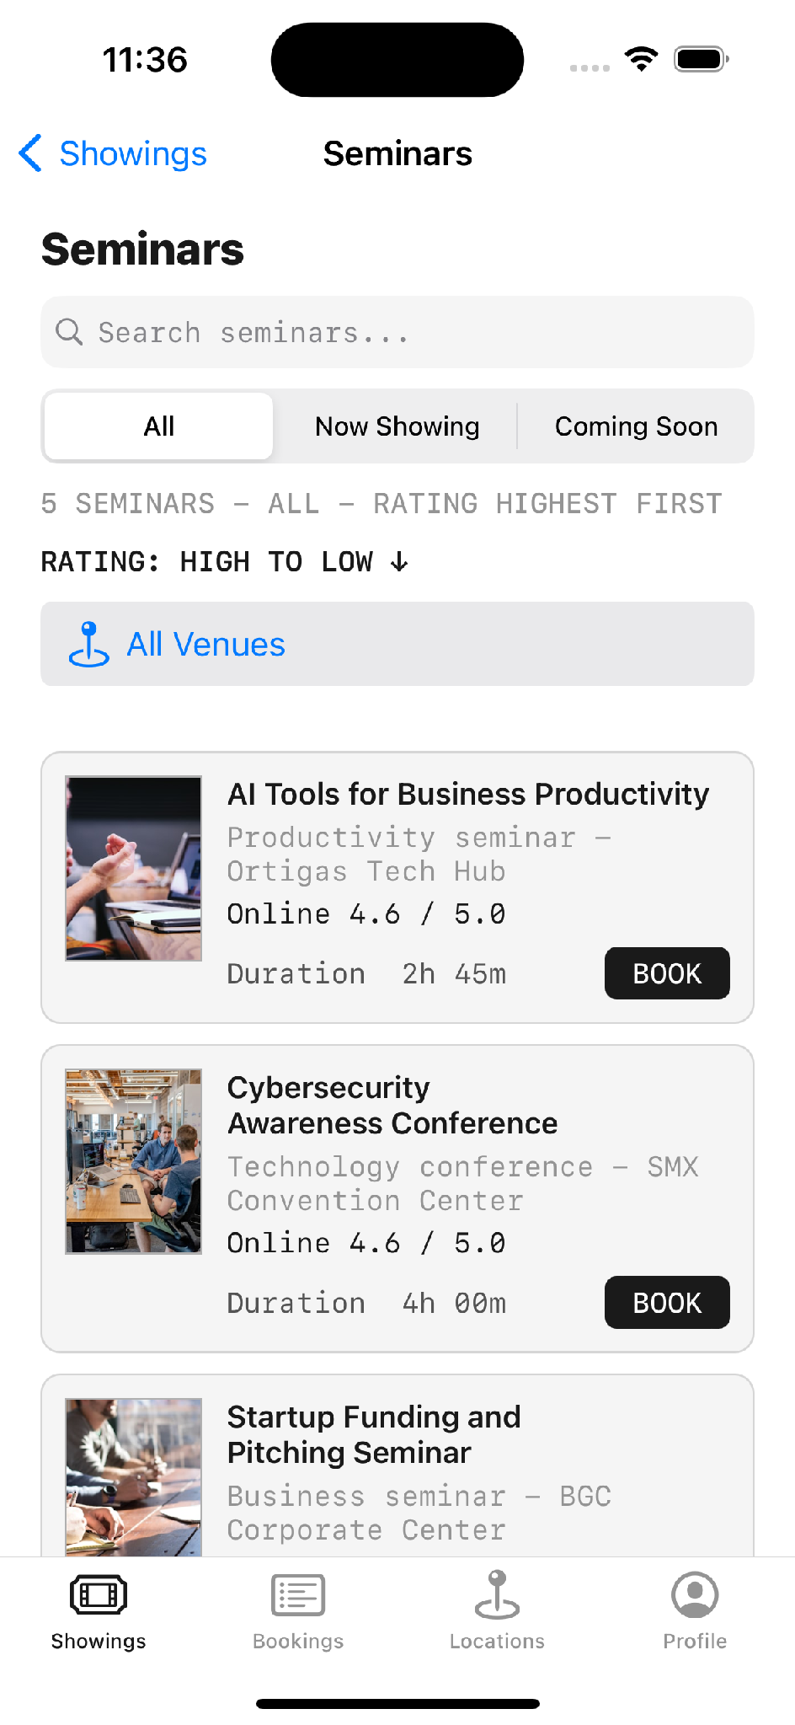
Concerts list | Concert detail | Seminars list

Chapter 9 — Testing
WHY A WHOLE CHAPTER Testing is a craft skill rather than a single API, which is exactly why it earns its own chapter rather than a footnote inside one of the seven topics. Xcode offers a testing system on the very first screen of every new project, and it is easy to accept the default and never think about it again. This chapter is what fills that gap — and it doubles as the most concrete possible demonstration of why the architecture in Topic 6 was worth the effort.

9.1 Why testing matters here
There are two reasons this chapter exists. The first is simple completeness: a developer who never learns to test has a blind spot that widens with every feature. The second is more interesting. Tests are the clearest possible payoff for the architecture taught in Topic 6 — protocol-based dependency injection can sound abstract until you watch it make a test possible that would otherwise be flatly impossible. The reference application carries 47 unit tests and 6 UI tests, and every one of them exists because the app was built to be testable in the first place. This chapter uses them to make the abstract concrete.
 | Unit tests | UI tests
Target | CineSeatTests | CineSeatUITests
Count | 47 test methods | 6 test methods
What they touch | View models, persistence, validation, business rules | The real app, tapped like a user
Speed | Fast — no app launch | Slow — launches the app each time
Framework | XCTest with `@testable import` | XCTest with `XCUIApplication`

A unit test reads like a specification
[ON SCREEN — XCODE] Open CineSeatTests.swift. This test is a good first one to show because you can predict what it asserts before reading it.
TicketPlease — the Module 2 search and sort logic, verified
func testMovieSearchAndRatingSortAcrossCategories() {
let viewModel = MoviesViewModel()
XCTAssertEqual(viewModel.movieCountText, "Movie library - 10 films")

viewModel.searchText = "dune"
XCTAssertEqual(viewModel.filteredMovies.map(\.title), ["Dune: Part Two"])

viewModel.searchText = ""
viewModel.toggleRatingSortOrder()
XCTAssertEqual(viewModel.filteredMovies.map(\.title).first,
"Avatar: The Way of Water")

viewModel.selectedCategory = .comingSoon
XCTAssertEqual(viewModel.filteredMovies.map(\.title), [
"Avatar: The Way of Water",
"Harry Potter and the Sorcerer's Stone"
])
}

WHY THIS TEST IS POSSIBLE AT ALL Because the search and sort logic lives in MoviesViewModel and not in the view controller. There is no storyboard here, no UIKit, no screen — the test creates a view model, sets properties and checks the output. Had that logic stayed in the view controller, as it did in the calculator exercise, this test could not be written. That is the MVVM argument made concrete, and it is the single best moment in the series to make it.

Fakes — the real payoff of protocol-based DI
Module 6 argued for depending on protocols rather than concrete types. Here is what that buys you. Because AuthenticationService accepts anything conforming to ProfilePersisting and PasswordStoring, the tests can hand it in-memory implementations instead of touching the file system or the real Keychain.
[ON SCREEN — XCODE] Scroll to the bottom of CineSeatTests.swift where the fakes are defined.
TicketPlease — three fakes, each satisfying a protocol from Module 6
// Real code writes to Documents/profiles.json. Tests use this instead.
private final class InMemoryProfileRepository: ProfilePersisting {
var profiles: [UserProfile] = []

func loadProfiles() throws -> [UserProfile] { profiles }
func saveProfiles(_ profiles: [UserProfile]) throws { self.profiles = profiles }
}

// Real code writes to the iOS Keychain. Tests use a dictionary.
private final class InMemoryPasswordStore: PasswordStoring {
private var passwords: [UUID: String] = [:]

func savePassword(_ password: String, accountID: UUID) throws {
passwords[accountID] = password
}
func password(accountID: UUID) throws -> String? { passwords[accountID] }
func deletePassword(accountID: UUID) throws { passwords[accountID] = nil }
}

// Real code calls TMDB over the network. Tests return canned data.
private final class FakeOnlineReviewFetcher: OnlineReviewFetching {
let reviews: [OnlineReview]
func fetchReviews(movieID: Int) async throws -> [OnlineReview] { reviews }
}

THE POINT TO LAND None of these fakes required changing a single line of production code. They exist purely because the production types depend on protocols. Without that, testing the login flow would mean writing real files to disk, storing real passwords in the Keychain, and making real network calls to TMDB — slow, flaky, and dependent on an internet connection.

Testing things that are genuinely hard to test
Two examples worth showing, because they answer the objection that tests only ever check trivial things.

The Keychain, for real
TicketPlease — exercising the real Keychain safely
func testKeychainPasswordStoreSavesReadsAndDeletesPassword() throws {
// A unique service name per run keeps test data out of the real store
let store = KeychainPasswordStore(service: "CineSeatTests.\(UUID().uuidString)")
let accountID = UUID()
defer { try? store.deletePassword(accountID: accountID) } // always clean up

try store.savePassword("MoviePass2026", accountID: accountID)
XCTAssertEqual(try store.password(accountID: accountID), "MoviePass2026")

try store.deletePassword(accountID: accountID)
XCTAssertNil(try store.password(accountID: accountID))
}

TWO TECHNIQUES IN FOUR LINES A unique service name per test run means the test never collides with real stored passwords, and defer guarantees cleanup even if an assertion fails partway through. Both are small habits that separate a test suite you trust from one you learn to ignore.

A time-dependent business rule
The review system has four ownership gates, one of which is that the showtime must already have passed. That is exactly the kind of rule that is painful to verify by hand — you would have to wait, or change the device clock.
Four tests covering the review eligibility rules from the 1 July milestone
func testReviewEligibilityRequiresConfirmedPastBooking() { /* ... */ }
func testReviewEligibilityOpensAfterTheScheduledStartTime() { /* ... */ }
func testDeveloperModeCanBypassReviewTime() { /* ... */ }
func testReviewWritingIsOnlyExposedFromBookingDetail() { /* ... */ }

WHAT THE TEST NAMES DO Read those four names in order and you have the specification for the entire review feature — no comments, no separate document. That is worth pointing out as a documentation practice in its own right, and it links directly to the documentation chapter: a well-named test is documentation that cannot go out of date, because it fails when it becomes untrue.

UI tests — tapping the app like a user
[ON SCREEN — XCODE] Run this UI test on camera. Watching the simulator drive itself is the most compelling thirty seconds in this section.
TicketPlease — a UI test walking the booking flow
// module 2 ui tests
// these tap the same storyboard buttons and table cells shown in the app
func testMovieToSeatSelectionFlow() throws {
let app = XCUIApplication()
app.launch()

XCTAssertTrue(app.staticTexts["TicketPlease Showings"].waitForExistence(timeout: 3))
app.buttons["showingCategory_Movies"].tap()
app.segmentedControls.buttons["All"].tap()

let firstMovie = app.tables.cells["movieCell_Star Wars: Episode IV - A New Hope"]
XCTAssertTrue(firstMovie.waitForExistence(timeout: 3))
firstMovie.tap()

XCTAssertTrue(app.navigationBars["Movie Detail"].waitForExistence(timeout: 2))
app.buttons["movieReviewsButton"].tap()

// Showing pages are read-only — the write button must NOT be there
XCTAssertFalse(app.buttons["reviewActionButton"].exists)

app.navigationBars["Reviews"].buttons["Movie Detail"].tap()
app.buttons["SELECT SEATS"].tap()
XCTAssertTrue(app.navigationBars["Select Seats"].waitForExistence(timeout: 2))
}

[ON SCREEN — IPHONE] Show these three screens as the test walks through them.
Tap a movie cell | Assert no write button | Land on seat selection

Technique | Why it matters
waitForExistence(timeout:) | UI tests are asynchronous. Asserting immediately produces tests that fail at random.
Accessibility identifiers | `movieCell_...` and `showingCategory_Movies` are stable hooks. Matching on visible text breaks the moment copy changes — and makes the app more accessible as a side effect.
Asserting absence | `XCTAssertFalse(...exists)` proves the read-only rule holds. Checking that something is NOT there is often the more valuable test.
launchArguments | `-resetProfileSessionForUITests` puts the app in a known state before the test runs.
continueAfterFailure = false | Stops at the first failure, so you debug the real cause rather than a cascade.

What the suite actually covers
Area | Examples
Content rules | 10 films present, JSON split by category, offline posters exist, writable Documents copies created
Business logic | Search, rating sort, category filters, cinema rotation, seat availability, peso totals
Persistence | Bookings saved and reloaded as JSON, settings as plist, seat layouts from plist, UserDefaults preferences
Security | Keychain save / read / delete, duplicate account rejection, invalid login rejection, validation rules
Review rules | Ownership, confirmation, showtime passed, one review per item, Developer Mode bypass, TMDB kept separate
Regression guards | Brand name, TP booking prefix, rating text format, duration normalisation

AN HONEST CAVEAT The reference application's tests were written alongside its features, not strictly before them, and there is no formal coverage target. That is entirely normal for a project of this size, and it is worth saying rather than glossing over. The claim this chapter makes is not that the app is exhaustively tested — it is the more useful point that the architecture from Topic 6 made testing possible at all, and that a suite of this shape is realistically achievable inside a short build rather than being a luxury reserved for large teams.

VERSION NOTE (2026) Xcode 26 ships Swift Testing alongside XCTest — the newer framework using @Test and #expect in place of test-prefixed methods and XCTAssert. It is what the project template now offers by default for new test targets. XCTest is not deprecated and remains required for UI testing, so this app's suite is entirely valid; but a viewer creating a new project today will likely see Swift Testing first, and should not be confused by the difference.
Source: developer.apple.com — Swift Testing

Chapter 10 — Documentation Best Practices
WHY A WHOLE CHAPTER Documentation is the second craft skill no single API teaches, and it is the one that decides whether any of the work in the preceding topics can actually be handed to someone else. A change list — a dated record of what changed and why — is the artefact a team, a reviewer or a client will genuinely read, and writing a good one is a learnable skill in its own right. This chapter teaches it the same way the rest of the guide teaches everything: with a real, worked example.

10.1 Why documentation matters
Every topic so far answered a version of 'how do I build this?'. This chapter answers a different and quieter question: six months from now, when someone else opens the project — or when you open your own project and have forgotten every decision you made — what is there to tell them what happened and why? Code is very good at recording what the software does. It is almost useless at recording what was tried and abandoned, what broke, what was deliberately left out, and where AI assistance was used. That gap is exactly what documentation fills, and it is the difference between a project that can be handed over cleanly and one that effectively cannot be handed over at all.
THE STANDARD TO AIM FOR There is a simple test for whether documentation is good enough: a change list is doing its job when someone can reconstruct the reasoning behind the current state of the code without having to ask the original author a single question. Everything below is in service of that one standard.

10.2 The five parts of a documented change
[GRAPHIC] Animate these five fields as a stacked card that assembles one row at a time, so the viewer sees a single change-list entry being built up field by field. Emphasise the last two — Difficulties and Solutions — since those are the ones people skip and the ones that carry the real value.
Field | What goes in it | Why it matters
Date | The actual calendar date, with the day of the week | Anchors the change to a point in the project's history
What changed | A factual summary of what shipped, in plain language | The reader needs this before anything else
AI involvement | Whether AI was used, which tool, for what, and what you verified | Honesty about provenance; reviewers need to know what to check harder
Difficulties | What actually went wrong or took longer than expected | The most valuable and most frequently skipped field
Solutions | How each difficulty was resolved, and what you would do differently | Turns a problem into reusable team knowledge

10.3 A worked example — the reference app's change list
The most effective way to teach documentation is to show a real change list rather than describe an ideal one. The reference application ships its change list inside the app itself, on the Settings screen, so it is visible to anyone using the build rather than buried in a repository few users will ever open — a small decision that quietly signals the whole app takes its own history seriously.
[ON SCREEN — IPHONE] Open Settings and slowly scroll the in-app changelog — this is the chapter's hero shot, and the fact that the change list lives inside the shipping app rather than in a text file is itself the point, so let the scroll linger long enough to read a couple of entries.
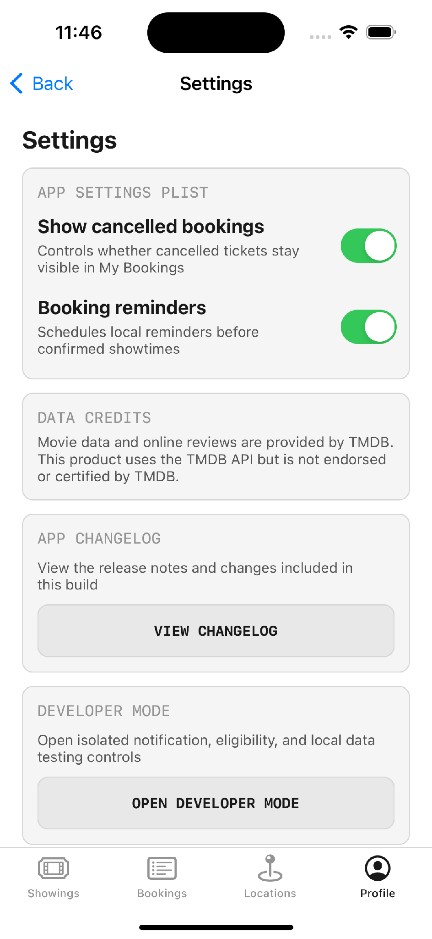 | 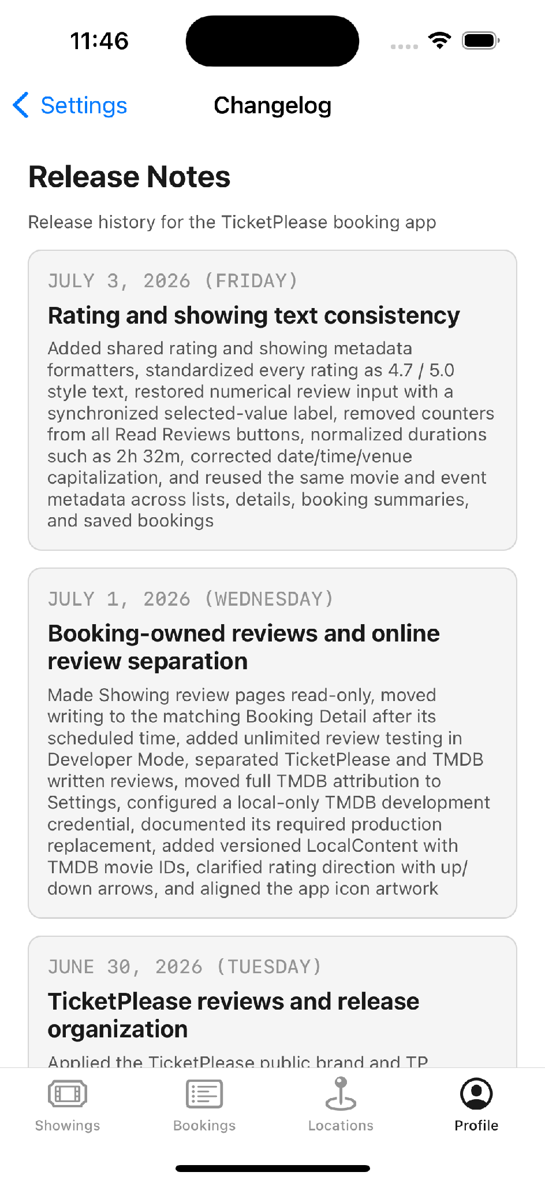
Settings screen | The change list, shipped inside the app

How it is stored in code
[ON SCREEN — XCODE] Open Constants/AppChangelog.swift.
TicketPlease — the changelog as structured, typed data rather than a loose text file
import Foundation

// release notes stay outside the settings viewmodel
enum AppChangelog {
static let entries: [SettingsChangelogEntry] = [
SettingsChangelogEntry(
day: "June 15, 2026 (Monday)",
title: "Initial setup and UIKit/MVVM structure",
details: "Created the project, storyboard tabs, Models/View/ViewModel folders, "
+ "outlet/action connections, table views, reusable cells, and the first "
+ "Movies, Bookings, and Profile flows"
),
SettingsChangelogEntry(
day: "June 17, 2026 (Wednesday)",
title: "Booking, profile, and persistence",
details: "Added movie detail, assigned showings, peso pricing, seat selection, "
+ "confirmation, account creation/login/logout/editing, session restore, "
+ "validation, Keychain passwords, and FileManager JSON persistence"
),
// ... nine further dated entries
]
}

WHY STRUCTURE IT Because it is a typed array rather than a Markdown file, the changelog can be rendered in the UI, tested, and never drifts out of sync with the build it ships in. The comment on line 3 is also doing documentation work — it explains a design decision, not the syntax.

10.4 The full change list, in the recommended format
Below is the reference application's change list expanded into the full five-field format. The dates and the 'what changed' column are the real project history; the difficulties and solutions show the format carrying the kind of information code alone never records. On camera, read two or three of these aloud rather than all eleven — the repeating shape of the entries is the lesson, not any single one of them, and the reader can study the rest at their own pace.

15 June 2026 (Monday) — Initial UIKit / MVVM setup
Field | Entry
What changed | Created the project, storyboard tabs, Models / View / ViewModel folders, outlet and action connections, table views, reusable cells, and the first Movies, Bookings and Profile flows.
AI involvement | AI used to look up UIButton styling properties during the earlier calculator exercise. All layout and structure written by hand and verified in the simulator.
Difficulties | Deciding folder structure before the app's shape was clear. Auto Layout constraints did not scale beyond one device size.
Solutions | Adopted the three-folder MVVM convention taught in Module 2 and let it grow. Deferred constraints to a later finishing pass, prioritising a working flow first — the standard advice for a layout that will not cooperate.

17 June 2026 (Wednesday) — Booking, profile and persistence
Field | Entry
What changed | Added movie detail, assigned showings, peso pricing, seat selection, confirmation, account creation, login, logout, editing, session restore, validation, Keychain passwords and FileManager JSON persistence.
AI involvement | None for the Keychain implementation — written directly against the Module 5 material and Apple's Security framework documentation.
Difficulties | Keychain save and read failed intermittently at first. Deciding where passwords should live relative to the profile JSON.
Solutions | Matched the encoding on both sides — UTF-8 to write, UTF-8 to read — which resolved the failures. Kept passwords entirely out of profiles.json and in the Keychain alone.

19 June 2026 (Friday) — Movie data, posters, cinema rules and seating
Field | Entry
What changed | Expanded movie data, ratings and schedules. Added offline posters with URL and cache fallback, rating sort, predetermined showings, eight cinemas, standard and VIP pricing, varied seat layouts and booking-detail seat maps.
AI involvement | None. Poster pipeline designed from the Module 4 async image-loading pattern.
Difficulties | Posters failed to display when the network was unavailable, and recycled table cells briefly showed the previous row's poster.
Solutions | Built a three-tier fallback — bundled asset, then FileManager cache, then URLSession download — so the app works fully offline. Added prepareForReuse to clear stale images on cell recycling.

22 June 2026 (Monday) — Schedules, notifications and architecture cleanup
Field | Entry
What changed | Added nested one-week schedules, multiple showtimes, live current-date labels, local reminders via UserNotifications without APNs, Clean Architecture folders, protocol-based DI, use cases, AppFactory, DTOs and mappers.
AI involvement | None. Architecture refactor followed the Module 6 material directly.
Difficulties | View models had grown large and were reaching into concrete stores directly, making them hard to test. APNs was not viable without a paid developer account or a backend.
Solutions | Introduced protocol contracts in a Domain layer and moved all concrete wiring into AppFactory as a composition root. Used local UserNotifications instead of APNs, which meets the same user-facing requirement with no server.

23 June 2026 (Tuesday) — Plist settings, seat database and UI polish
Field | Entry
What changed | Added plist settings and a Settings menu, plist-backed seat layouts, shared UI constants, code comments, first unit tests, hidden technical paths, larger small fonts, warning fixes, persisted reserved seats and confirmed booking reset controls.
AI involvement | None.
Difficulties | Seat layouts hard-coded in Swift meant a code change for every cinema variation. Compiler warnings had accumulated.
Solutions | Moved seat layouts into a plist with an editable Documents copy, so layouts become data rather than code. Cleared all warnings before adding new work, and added the first unit tests to lock the behaviour in.

24 June 2026 (Wednesday) — Showings expansion, maps, sharing and launch cleanup
Field | Entry
What changed | Renamed the Movies tab to Showings, added Movies / Concerts / Seminars selection, event JSON and browsing screens, Locations MapKit pins and zoom buttons, ticket sharing by account email, empty launch bookings and separate device storage for runtime data.
AI involvement | None. MapKit implementation followed the Module 7 material.
Difficulties | The app shipped with generated sample bookings, which made a fresh install look wrong. Adding two new content types risked duplicating the entire movies flow.
Solutions | Made new installs start genuinely empty, with runtime data written to a separate device location. Generalised the showings model so concerts and seminars reuse the existing engine instead of copying it.

25 June 2026 (Thursday) — Interactive cinema pins and showtime shortcuts
Field | Entry
What changed | Added MapKit pin callouts, Cinema Details, grouped assigned showtimes, preselected movie dates and times, scalable showtime lists, Apple Maps pins and assigned-cinema-only booking.
AI involvement | None.
Difficulties | Users could reach a booking for a showtime at a cinema that did not actually screen that film.
Solutions | Restricted booking to the cinema assigned to that showing, and made showtime chips preselect the date and time so the path from map to booking cannot produce an invalid combination.

29 June 2026 (Monday) — Concert / seminar booking and feature separation
Field | Entry
What changed | Kept the Showings category landing, separated Concert and Seminar models and screens, added search and venue filters, coordinate-backed venues, live schedules, quantity booking, reminders, sharing, cancellation, history, venue details, an app icon and further tests.
AI involvement | None.
Difficulties | Concert and seminar logic had been sharing files and was becoming difficult to follow.
Solutions | Split them into separate models and view controllers while keeping the shared reservation core, following the guideline of one view model per file, so a bug in one feature never forces edits to another.

30 June 2026 (Tuesday) — TicketPlease rebrand and review system
Field | Entry
What changed | Applied the TicketPlease public brand and TP booking IDs, standardised Movie / Concert / Seminar list controls, replaced bundled reviews with account-owned FileManager JSON reviews, added Booking Detail review eligibility and one-review create / edit / delete rules, isolated testing controls in Developer Mode and organised bundled JSON under LocalContent.
AI involvement | None.
Difficulties | Bundled placeholder reviews were indistinguishable from real user reviews. Test data was polluting the same store as genuine data.
Solutions | Replaced bundled reviews with account-owned records so every review has a verifiable author. Isolated all testing affordances behind Developer Mode so test activity never contaminates real data.

1 July 2026 (Wednesday) — Booking-owned reviews and online review separation
Field | Entry
What changed | Made Showing review pages read-only and moved writing to the matching Booking Detail after the scheduled time. Added unlimited review testing in Developer Mode, separated TicketPlease and TMDB written reviews, moved full TMDB attribution to Settings, configured a local-only TMDB development credential, documented its required production replacement, added versioned LocalContent with TMDB movie IDs, clarified rating direction with arrows and aligned the app icon artwork.
AI involvement | None for the implementation. TMDB's API documentation consulted directly for the reviews endpoint.
Difficulties | Anyone could review anything, including films they had not seen. External TMDB reviews risked being averaged into the app's own ratings. The API token needed to exist somewhere without being committed.
Solutions | Added four ownership gates — signed in, owns the ticket, booking confirmed, showtime passed. Kept TMDB reviews in a separate segment that never enters reviews.json or the TicketPlease average. Stored the token only in the local Xcode scheme and documented in the README that it must be rotated and moved to a backend before release.

3 July 2026 (Friday) — Rating and showing text consistency
Field | Entry
What changed | Added shared rating and showing metadata formatters, standardised every rating as 4.7 / 5.0 style text, restored numerical review input with a synchronised selected-value label, removed counters from Read Reviews buttons, normalised durations such as 2h 32m, corrected date / time / venue capitalisation and reused the same metadata across lists, details, booking summaries and saved bookings.
AI involvement | None.
Difficulties | The same film's rating and duration were formatted differently on different screens, which looked like a data bug rather than a formatting inconsistency.
Solutions | Extracted RatingDisplayFormatter and ShowingMetadataFormatter as shared constants and routed every screen through them, so a formatting change now happens in exactly one place.

10.5 Documenting AI involvement
This field deserves its own treatment because it is new, it is increasingly expected by employers and clients, and most people get it wrong in one of two directions — either over-reporting every trivial autocomplete, or saying nothing at all and leaving a reviewer to guess.
The healthy position is neither avoidance nor concealment. AI assistants should be used, and used well — made an ally rather than a secret. The professional standard is simply transparency: record where an assistant helped, at what depth, and what you did to verify the result. It is worth remembering the contrast with how this work was done only a few years ago, when the answer to every unfamiliar problem was a search engine, Stack Overflow, and patience; the tools have changed, but the obligation to understand what you ship has not.

What to record
- The tool. Which tool, and which model or version if known.
- What it was used for. Scope matters. 'Looked up UIButton styling properties' is very different from 'generated the seat map layout logic'.
- What you verified. Did you run it? Did you read it line by line? Did you understand it well enough to debug it?
- What you changed. If you rewrote or rejected the suggestion, say so. That is evidence of judgement.

A four-level scale you can reuse
Level | Meaning | Example wording
None | Written entirely by hand | "None."
Reference | AI used the way documentation would be | "Used AI to look up available UIButton styling properties. Implementation written by hand."
Assisted | AI produced a draft that was then reworked | "AI produced an initial constraint set; rewritten to use stack views and verified on three device sizes."
Generated | AI produced code used largely as-is | "Boilerplate DTO generated from a sample JSON response; field names and optionality checked against the live API."

THE RULE THAT MATTERS MOST Never commit AI-produced code you cannot explain. If you could not debug it at two in the morning without the assistant, you do not understand it yet — and the honest entry in the change list is the one that says so.

10.6 Documenting difficulties honestly
The difficulties field is the one people delete before sharing a document, and it is the one with the highest value. A change list without difficulties reads like marketing. With them, it reads like engineering.
The difficulties below are the ones that recur for almost everyone learning this material, collected here as a reference. They make excellent teaching content precisely because they are universal — every one of them is a wall that most beginners hit, which means naming them openly reassures a struggling viewer that they are on the normal path rather than a lost one.
Difficulty | Why it happens | How it is resolved
Auto Layout constraints | Reliably the hardest topic for newcomers. Layouts that look correct on one device break on another. | Stop treating it as a blocker. Build the working flow first and treat constraints as a finishing pass. Constrain stack views as groups rather than each control individually.
Brute-force UI code | The first calculator created and styled every button individually — a lot of duplicated code. | Tagged the buttons in the Attributes Inspector, grouped them by purpose, and used arrays plus a single action per group.
Oversized view model files | Movies and Bookings view models were combined in one file, which grew quickly. | Split into one view model per file, on the reasoning that a bug in one feature should never require touching another feature's file.
Push navigation silently failing | The code was correct but the view controller was not inside a UINavigationController. | Set a Navigation Controller as the root and Ctrl-dragged to assign the root view controller.
Empty table views | Delegate and data source were never assigned, so the table rendered blank with no error. | Assigned both in viewDidLoad — the standard fix, and the reason initialisation belongs there.
"This class is not key value coding-compliant" | A storyboard outlet is still connected to a property that has since been renamed or deleted. | Open the Connections Inspector, remove the stale connection, and re-drag it. One of the most common storyboard crashes there is.
Crash on unwrapping nil | Force-unwrapping an optional that had no value at runtime. | Added an exception breakpoint in Xcode to find the exact line, then replaced force-unwraps with guard and if-let.
Credential handling | An API token was needed locally but must never ship inside the app. | Stored only in the local Xcode scheme as an environment variable, kept out of source and documentation, with the required production rotation written into the README.

[B-ROLL] Screen-record adding an exception breakpoint in Xcode — Debug menu, Breakpoints, Create Exception Breakpoint. It is a genuinely useful thirty seconds for viewers.

10.7 Templates to copy
Two templates the team can lift directly.

Template A — a single change-list entry
Markdown template — drop into CHANGELOG.md
### <DD Month YYYY> (<Day of week>) — <Short title>

**What changed**
<Plain-language summary of what shipped. Facts, not intentions.>

**AI involvement**
<None | Reference | Assisted | Generated> — <tool>, used for <scope>.
Verified by <how you checked it>.

**Difficulties**
<What actually went wrong, or took longer than expected. Be specific.>

**Solutions**
<How each difficulty was resolved. Note anything you would do differently.>

**Files touched**
<Optional: key paths, so a reviewer knows where to look.>

Template B — the in-app structured entry
Swift template — matches the AppChangelog pattern shown earlier
SettingsChangelogEntry(
day: "<Month DD, YYYY> (<Weekday>)",
title: "<Short title>",
details: "<Comma-separated summary of what shipped>"
)

10.8 Checklist
A closing checklist that captures the whole chapter in one place — as useful for a self-study reader auditing their own project as for a video editor. On camera it works beautifully as an animated list, each line ticking in as the narrator reads it, building to a sense of a complete, professional standard.
[GRAPHIC] Animate the list one line at a time, each item ticking in with a satisfying check as it is read aloud. Building the whole checklist on screen and then holding on the finished list gives the chapter — and, if this is the last episode, the whole series — a clean, definitive final beat.
- Every entry carries a real date, including the day of the week.
- 'What changed' is written in plain language a non-developer could follow.
- AI involvement is stated on every entry, including when the answer is 'none'.
- Difficulties are recorded honestly, not sanitised after the fact.
- Every difficulty has a matching solution, so the entry is useful to someone else.
- Decisions that were deliberately not taken are recorded too — such as choosing FileManager over Core Data.
- Known limitations live in a separate, findable document rather than being implied by silence.
- Credentials and secrets are never in the change list, the source, or the repository.
- The changelog ships with the build, so it can never drift out of sync with it.
- Comments in code explain why a decision was made, not what the syntax does.
A CLOSING LINE Seven topics teach how to build an iOS application. Testing proves it works. Documentation is what makes that work survivable by somebody else — including the version of you who opens the project a year from now with no memory of how it fits together.

Appendix A — Screenshot Asset Index
All screenshots are iPhone portrait, 1179 × 2556 px. Source files live in the project at CineSeat/PresentationAssets/screenshots/. Filenames below are exact.
Diagram | Shows | Location | Used in
flowchart_booking.png | The full booking flowchart, 1500 × 2560 px | CineSeat/PresentationAssets/ | Ch 8

File | Shows | Used in
01_showings_landing.png | Showings hub — category landing | Overview, M2
02_movies_list.png | Movies list with search, filter, sort | M1, M2
03_movie_detail.png | Movie detail screen | M1, M2, Ch 8
04_reviews_ticketplease.png | App's own reviews | M4
05_reviews_online_tmdb.png | TMDB online reviews | M4
06_datetime_showtimes.png | Date and showtime selection | Ch 8
07_seat_map.png | Interactive seat map | Overview, M6, Ch 8
08_booking_summary.png | Booking summary | M5, Ch 8
09_booking_confirmation.png | Booking confirmed | Overview, M5, Ch 8
10_concerts_list.png | Concerts list | Ch 8
11_concert_detail.png | Concert detail | Ch 8
12_concert_quantity.png | Quantity booking | Ch 8
13_seminars_list.png | Seminars list | Ch 8
14_seminar_detail.png | Seminar detail | —
15_bookings_list.png | Booking history | M2, M5
16_booking_detail.png | Booking detail with seat map | M6
16b_booking_detail_actions.png | Booking detail actions | —
17_review_editor.png | Review editor | —
17b_review_input.png | Numerical review input | —
19_locations_map.png | MapKit pins | Overview, M2, M7
20_pin_callout.png | Pin callout | M7
21_cinema_detail.png | Cinema details | M7
22_profile_account.png | Profile / account | M2, M5
23_edit_profile.png | Edit profile | M5
24_settings.png | Settings | Ch 10
25_changelog.png | In-app change list | Ch 10
26_developer_mode.png | Developer Mode | Overview
27_notification_banner.png | Notification banner | M7
28_notification_lockscreen.png | Lock screen notification | M7

Appendix B — Glossary
Term | Meaning
APNs | Apple Push Notification service — Apple's remote push system. Requires a paid developer account.
ARC | Automatic Reference Counting — Swift's automatic memory management.
Auto Layout | Constraint-based layout system that scales a UI across device sizes.
Bundle identifier | The app's globally unique ID. Cannot be duplicated across App Store accounts.
Codable | Swift protocol enabling automatic encoding and decoding between JSON and models.
CodingKeys | Maps Swift property names onto differently-named JSON keys.
Composition root | The single place where concrete dependencies are chosen — AppFactory in this app.
Core Data | Apple's object-graph and persistence framework for structured relational data.
DTO | Data Transfer Object — the shape data arrives in, before mapping to a domain model.
Delegate | A protocol-based callback for interaction and events.
Data source | A protocol supplying content — how many rows, and what is in each.
GCD | Grand Central Dispatch — Apple's older concurrency API.
Interface Builder | Xcode's visual UI editor, used with storyboards and XIBs.
Keychain | OS-encrypted secure storage for passwords, tokens and sensitive data.
Leading / trailing | Reading-direction-aware equivalents of left and right.
MVC | Model-View-Controller. The default structure of a UIKit app.
MVVM | Model-View-ViewModel. Moves logic out of the controller into a reusable view model.
Outlet / Action | An outlet connects a control as an object; an action connects its behaviour.
PHPicker | The modern photo library picker. 'PH' is Photos.
Protocol | A contract of methods and properties that a type promises to provide.
Safe area | The region of the screen not obscured by notches, home indicators or bars.
Segue | A storyboard-defined transition between scenes. Simple, but inflexible.
Singleton | A single shared instance accessed globally — UserDefaults.standard is one.
Storyboard | A visual file holding multiple view controllers and their transitions.
UIKit | Apple's classic, event-driven UI framework. The focus of this curriculum.
SwiftUI | Apple's newer declarative UI framework. Deliberately out of scope here.
UserDefaults | Lightweight key/value storage for small preferences and flags.
XIB / NIB | An Interface Builder file for a single view, unlike a storyboard.

Appendix C — Accuracy, Misconceptions and Currency Notes
Every technical claim in this guide was checked against Apple's documentation and current industry sources in July 2026. This appendix is the audit trail behind that. It exists so a reviewer can verify any single item without re-reading the chapter it came from, and so an editor can see at a glance which points are stable fundamentals and which are time-sensitive and may need refreshing before a future re-release.
HOW TO USE THIS TABLE The MISCONCEPTIONS section lists widely-held beliefs that are simply untrue; teach the corrected version and never the myth. The CURRENCY section lists material that was accurate for an earlier era of the platform but has since moved on. The ADDED section lists topics included because a modern viewer will inevitably ask about them.

C.1 Misconceptions to correct
# | Topic | The myth | The reality
1 | UserDefaults security | Passwords can be stored in UserDefaults; it is "secure" and "automatically encrypted" on iOS | UserDefaults is not encrypted. It is a plaintext .plist in the app container with no access control, readable via filesystem access or an unencrypted backup. Credentials belong in the Keychain.
2 | map | map "finds the specific number you need" | map transforms every element and returns a collection of the same length. Searching is first(where:). filter selects a subset; reduce collapses to one value.
3 | unowned | unowned "just stays in memory" | unowned does not retain the object. It is non-optional and is never nilled out, so accessing it after deallocation crashes. Prefer weak unless the lifetime guarantee is explicit.
4 | HTTP status codes | Error codes referred to as "402" | 402 Payment Required is effectively unused. The relevant codes are 200/201 success, 400/401/403/404/429 client errors, 500 server error. Teach the (200...299) range check.
5 | MapKit vs Google Maps | Use Google Maps instead of MapKit; it is "more developed" | A trade-off, not a clear win, and the cost was omitted. MapKit is free for native apps with no API key or billing. Google Maps requires a billing account and card before issuing a key, but offers richer place metadata.
6 | Swift release date | Swift began "around 2014, 2015, 2016" | Announced 2 June 2014 at WWDC; Swift 1.0 shipped 15 September 2014; open-sourced 3 December 2015.
7 | Photo pickers | UIImagePickerController presented as simply the easier option | Soft-deprecated since iOS 14 — annotated "will be removed in a future release, use PHPicker". PHPicker is correct for the library; UIImagePickerController is still required for camera capture.

C.2 Currency updates
# | Topic | Earlier-era position | Position in July 2026
8 | Toolchain | Xcode with the iOS 17.5 SDK | Xcode 26.x with Swift 6.3, targeting iOS 26. Xcode 26.6 requires macOS Tahoe 26.2 or later.
9 | App Store submissions | Not covered | Since 28 April 2026, all App Store Connect uploads must be built with the iOS 26 SDK or later using Xcode 26 or later. No grace period.
10 | System requirements | 8 GB RAM minimum, 20 GB storage | 16 GB is the realistic baseline; Predictive Code Completion requires 16 GB unified memory and Apple silicon.
11 | CocoaPods | Taught as the primary dependency manager | In maintenance mode since August 2024. Registry becomes permanently read-only on 2 December 2026. Swift Package Manager is now the default choice.

C.3 Added — topics a modern viewer will ask about
# | Topic | Why it was added
12 | SwiftData | Apple's iOS 17+ persistence framework. Viewers will ask how it relates to Core Data; the honest answer includes its current performance and API-stability caveats.
13 | UIKit vs SwiftUI in 2026 | The obvious viewer question — "why learn UIKit?" — deserves a direct, evidenced answer rather than silence.
14 | Keychain accessibility classes | The reference app uses kSecAttrAccessibleAfterFirstUnlockThisDeviceOnly; this is the attribute that determines whether a credential can be lifted from a device backup, so it is worth explaining.
15 | Exact Info.plist permission keys | The keys must be typed exactly, and a missing purpose string is a common App Store rejection — so the precise strings are listed rather than described in general terms.
16 | APNs true cost | The USD 99/year Developer Program requirement, server needs and annual certificate rotation explain why a small app sensibly uses local notifications instead.
17 | Local notification limits | Local notifications cannot respond to external events — a limitation worth naming so a learner understands when APNs is genuinely required.

C.4 Sources
Primary references used to verify the items above.
- Apple Developer Documentation — Xcode 26.6 Release Notes, MapKit, PHPickerViewController, Security framework (kSecAttrAccessible), Automatic Reference Counting
- CocoaPods Blog — maintenance mode announcement and support plans (blog.cocoapods.org)
- Appknox — Insecure iOS Data Storage: Risks, Examples, and Secure Implementation
- PTKD Journal — iOS Keychain vs UserDefaults: where to store tokens
- NowSecure — Secure Mobile Development Best Practices: Use the Keychain Carefully
- Google — Maps SDK for iOS Usage and Billing
- SwiftLee (avanderlee.com) — Weak self and unowned self explained in Swift
- fatbobman.com — Why I'm Still Thinking About Core Data in 2026
- 7Span / Nevina Infotech — SwiftUI vs UIKit 2026 framework comparisons and adoption survey data
- TechCrunch, 2 June 2014 — Apple Launches Swift
MAINTENANCE NOTE Apple's release cadence means the currency items (8 to 11) will need revisiting if this series is republished or extended down the line. The misconceptions in C.1 are stable — they are language and security fundamentals, and they will not change.

Appendix D — Common Xcode Errors and How to Fix Them
This appendix is a field guide to the errors that beginners actually hit, and the exact sequence that fixes each one. It is deliberately practical rather than exhaustive: every entry is a problem common enough that almost anyone learning iOS will meet it, paired with the specific steps that resolve it rather than a vague 'check your code'. For a self-study reader it is a troubleshooting reference; for the video, it is ready-made content.
A STRONG STANDALONE VIDEO This appendix works well as its own short episode, or as a recurring 30-second segment closing each of the main episodes. Because every entry is a genuinely common failure with a concrete fix — not a generic 'debugging tips' list — it carries the credibility that only specificity gives, and it is the kind of content viewers bookmark and return to.

D.1 Storyboard and connection errors

"This class is not key value coding-compliant for the key ..."
Symptom | The app builds fine, then crashes the instant the screen loads.
Cause | A storyboard outlet is still wired to a property that was renamed or deleted in code. The storyboard is looking for something that no longer exists.
Fix | Open the storyboard, select the view controller, open the Connections Inspector (the last tab, the arrow icon). Find the connection with a yellow warning triangle and delete it. Re-drag it if the control is still needed.
Prevention | Delete the connection in Interface Builder before renaming or removing the property in code, not after.

THE VARIANT THAT CONFUSES PEOPLE The same crash appears if the view controller's Class field in the Identity Inspector points at the wrong class — or was never set at all. A very common version of this: a scene's class is left as the default UIViewController rather than the custom subclass, so none of its outlets can resolve and the screen crashes on load. Always check the Class field first; it is far faster than auditing every individual connection.

An outlet or action will not connect at all
- Most common cause: The view controller's Class in the Identity Inspector does not match the Swift file you are dragging into. Set it first — you cannot connect to a class the storyboard does not know it is using.
- Second cause: Outlets go inside the class but above viewDidLoad. Actions go below its closing brace. Dragging to the wrong place produces a connection that will not compile.
- Third cause: Xcode occasionally loses the assistant editor pairing. Close it, reopen with the plus button and Editor pane on right, and re-point it at the correct file.

D.2 Runtime crashes

"Unexpectedly found nil while unwrapping an Optional value"
Symptom | Crash on a line containing `!`, or on an implicitly unwrapped outlet.
Cause | A force-unwrap on something that had no value at runtime. Frequently an outlet that was never connected, or data that had not loaded yet.
Fix | Replace the force-unwrap with `guard let` or `if let`. If it is an outlet, confirm it is actually connected in the storyboard.
Find it fast | Add an exception breakpoint — see D.4 below. It stops on the exact line rather than in assembly.

THE MODULE 1 LESSON, PAYING OFF This is the crash optionals exist to prevent, and it remains the most common crash beginners hit. A good moment to restate the core principle from the very first topic: bugs are acceptable, crashes are not.

D.3 Silent failures — nothing crashes, nothing happens
Symptom | Cause | Fix
Table view renders completely empty | `delegate` and `dataSource` were never assigned | Set both in `viewDidLoad`. No error is produced — the table just stays blank.
Tapping a button does nothing | Connected as an outlet but never as an action | Ctrl-drag a second time, below `viewDidLoad`, and choose Action.
Push navigation does nothing | The view controller is not inside a `UINavigationController` | Add a Navigation Controller and set your screen as its root view controller.
The first screen is black on launch | The navigation controller's root view controller was never set | Ctrl-drag from the navigation controller to the intended screen, choose 'root view controller'.
Location, camera or photos silently unavailable | Missing `Info.plist` purpose string | Add the exact key — see Module 7 — with a plain-language reason.
Images appear in the wrong table rows while scrolling | Cell reuse without clearing old content | Reset the image in `prepareForReuse()`.
Layout looks correct on one device, broken on another | Missing or conflicting constraints | Build the layout with stack views and constrain the stack, not each control.

D.4 Debugging techniques from the sessions

Exception breakpoints — the highest-value thirty seconds in this appendix
When a crash lands in assembly with no useful line number, an exception breakpoint stops execution at the exact line that threw. This was used repeatedly in the mentoring sessions to turn an unreadable crash into an obvious one.
- Debug → Breakpoints. Open the Breakpoint Navigator, or use the Debug menu.
- Click the + at the bottom left. Choose Create Exception Breakpoint.
- Run again. The debugger now stops on the offending line instead of deep inside the framework.
[B-ROLL] Screen-record this. It is short, visual, and immediately useful to anyone watching.

Left-over breakpoints
A REAL ONE FROM THE SESSIONS A classic false alarm: the app appears to 'freeze' on launch. Very often it is not frozen at all — a forgotten breakpoint was pausing execution. The blue arrow markers in the gutter are easy to add by accident and easy to miss. Clear them, or use Debug → Deactivate Breakpoints, before assuming there is a bug.

Read the console, not just the crash
- Log first: `print()` in viewDidLoad and in each action, to confirm code is reached at all. Crude, but it was the first move in most sessions.
- Open the panel: The console panel at the bottom of Xcode is hidden by default in some layouts. It is easy to conclude there is no log output when the panel is simply collapsed.
- Read the top line: The first line of a crash log usually names the problem. Read it before changing anything.

D.5 Build and environment problems
Symptom | Fix
"No such module 'UIKit'" or missing SDK errors | The Xcode installation is out of date or incomplete. Update Xcode and let it finish installing platform support before opening the project.
Build succeeds but the simulator stays blank | Wait — the first launch after a clean build is slow. If it persists, check the console and confirm the root view controller is set.
Very slow builds and simulator launches | Largely hardware. Close unused simulators; each one consumes memory. See the current requirements in Module 1.
Project will not open after adding pods | Open the `.xcworkspace`, not the `.xcodeproj`. Note that new projects should use Swift Package Manager instead — see Module 4.
Accidentally deleted AppDelegate or SceneDelegate | The project will not build. Restore from version control — a good argument for committing early and often.

D.6 The debugging order used in the sessions
Across four days of consultations the same sequence emerged. It is worth stating as a checklist.
- 1. Read the actual error message. The top line usually names the problem.
- 2. Confirm the code is even running — add a print and check the console.
- 3. If it crashes, add an exception breakpoint to find the exact line.
- 4. If it is a storyboard problem, check the Identity Inspector Class field first, then the Connections Inspector.
- 5. If nothing happens at all, look for an unassigned delegate, data source or missing action.
- 6. Isolate: comment out the new code until it works, then reintroduce it a piece at a time.
- 7. Only then start changing things — and change one thing at a time.
THE CLOSING THOUGHT FOR THIS APPENDIX Almost none of these were logic errors. They were connection errors, missing assignments and absent configuration — the kind of thing no amount of Swift knowledge prevents and only familiarity with the tooling fixes. That is a genuinely encouraging message for beginners: being stuck usually means you have missed a checkbox, not that you cannot program.

